
www.FASTBusinessPlans.com

Sample Business Plan
for
Insurance Agency

Convenience Insurance
19221 North I-45
The Woodlands, TX

(Creation Date)

Use and Reprint Rights for Your FAST Business Plan Template

This sample insurance agency business plan has been written to assist you in creating your company specific business plan. You are free to edit and use the material within your organization. However, please do not distribute this document online or elsewhere publically without explicit permission from us.

Table of Contents

1.0 Executive Summary 4
1.1 Business Objectives 4
1.2 Mission Statement 4
1.3 Guiding Principles 4
1.4 Keys to Success 5
2.0 Company Description 7
2.1 Ownership 7
2.2 Legal Form 8
2.3 Start-Up Summary 8
2.4 Location and Facilities 9
3.0 Products 9
3.1 Products/Services Descriptions 9
3.2 Competitive Comparison 10
3.3 Product/Service Sourcing 10
3.4 Inventory Management 11
3.5 Warehousing and Fulfillment 11
3.6 Future Products/Services 11
4.0 Market Analysis 11
4.1 Industry Analysis 11
4.1.1 Market Size 12
4.1.2 Industry Participants 12
4.1.3 Main Competitors 12
4.1.4 Market Segments 14
4.2 Market Tests 15
4.3 Target Market Segment Strategy 15
4.3.1 Market Needs 16
4.3.2 Market Trends 16
4.3.3 Market Growth 16
4.4 Positioning 16
5.0 Marketing Strategy and Implementation 16
5.1 SWOT Analysis 16
5.1.1 Strengths 16
5.1.2 Weaknesses 17
5.1.3 Opportunities 17
5.1.4 Threats 17
5.2 Strategy Pyramid 17
5.3 Unique Selling Proposition (USP) 18
5.4 Competitive Edge 18
5.5 Marketing Strategy and Positioning 18
5.5.1 Positioning Statement 18
5.5.2 Pricing Strategy 18
5.5.3 Promotion and Advertising Strategy 19
5.5.4 Website 19
5.5.5 Marketing Programs 19
5.6 Sales Strategy 20
5.6.1 Sales Forecast 20
5.6.2 Sales Programs 21
5.7 Legal 21
5.8 Milestones 21
5.9 Exit Strategy 22
6.0 Organization and Management 22
6.1 Organizational Structure 22
6.2 Management Team 22
6.3 Management Team Gaps 22
6.4 Personnel Plan 22
6.5 Board of Directors 23
7.0 Financial Plan 23
7.1 Important Assumptions 23
7.2 Start-Up Costs 24
7.3 Source and Use of Funds 25
7.4 Break-Even Analysis 25
7.5 Projections 26
7.5.1 Projected Profit and Loss 26
7.5.2 Projected Cash Flow 27
7.5.3 Projected Balance Sheet 29
7.6 Business Ratios 30

Executive Summary
Convenient Insurance (“Convenient Insurance”) will be the newest and brightest independent insurance agency to The Woodlands, (Northern Houston), Texas. The owners Greg and Maria Bell have a combined 20 years experience and previously operated a captive insurance agency in downtown Houston. Desiring to offer a broader depth of products to better serve their clients’ needs, the Bells have closed their Houston office and are opening a new office closer to their home and neighbors in the master planned community known as the Woodlands. The Bells came up with the name Convenient Insurance – not just because of its location closer to their home, but also because this independent agency will offer convenience unparalleled to even the closest competitors. Convenient Insurance can meet client’s insurance needs at their home, place of business, or online. And with the latest technology available, customers can utilize the latest apps to setup reminders, make payments or view policies. Convenient Insurance is a member of The Independent Insurance Agents of Texas (“IIAT”) a proud member of the Trusted Choice Insurance Carriers. This affiliation with over 100 carriers covers virtually any and every life situation and life stage.

What really sets Convenient Insurance apart from its competitors are its people. The owners, Greg and Maria Bell are both Certified Financial Planners (“CFPs”). This designation is a professional certification mark for financial planners. CFP candidates must meet education, examination, experience, and ethics requirements. At Convenient Insurance, all customers will be required to take a needs based test to determine what, if any, insurance products are needed. Customers can rest assured that they will purchase only products that truly meet their needs and are legitimately warranted.

Business Objectives
Convenient Insurance believes that in order to provide the broadest (and best!) selection of insurance services the company must continue to grow. In order to grow the business, Convenient Insurance must meet the following objectives:
- Increase revenues 10% annually – thus capturing market share
- Attain direct appointments (explained in Section 3.3) by Year 4 – thus reducing annual expense. Reduced expenses in turn can allow for increased cash flow.

Mission Statement
Convenience Insurance wants to raise the bar in the insurance industry by providing excellence and the utilizing the highest principles and standards to every aspect of the business. Convenient Insurance wants to empower its clients, employees and community and urge them to employ these practices as well. Because when we all do our personal best, the payoff is always a win/win.

Guiding Principles
Convenient Insurance believes in honesty, integrity and transparency in an industry that is not known for these merits. Convenient Insurance believes:

- Honesty is the best policy. Convenient Insurance agents / staff will operate in a fair and equitable manner. For example, if a family that recently had a baby came into the office and wanted to buy that “new college savings account for baby which is also a life insurance policy”, Convenient Insurance would not sell this product because other products are much more cost efficient and specifically designed for saving for college. A life insurance policy is a life insurance policy. Period.

- Always be Consistent. Most agents chant the mantra “ABC” short for “Always Be Closing”. At Convenient Insurance, they believe in “Always Be Consistent”. Consistency in life is a good habit and one Convenient Insurance believes in. Consistency at Convenient Insurance means that each person/business is treated individually, with the greatest attention to detail. A satisfied customer is a happy person and in turn makes this world a little bit better place. (Also a happy customer will hopefully generate annual repeat business and referrals).

- A commitment to people. Without Convenient Insurance’s staff – well there is no Convenient Insurance. Convenient Insurance will work closely to hand select its team. All members will receive ongoing education which not only benefits the business but helps them grow as individuals as well. Convenient Insurance believes this holds true with its customers, vendors, and its community and Convenient Insurance will be just as passionate and committed to them as well.

Keys to Success
Everyone is familiar with the Golden Rule: Treat others how you would want to be treated. At Convenient Insurance, they take this one step further - - Treat others better than you would treat yourself! Convenient Insurance wants to be known as the agency of choice, with a vast selection of products designed to meet every need, delivered by trained professionals, selling only need-based products, in a technologically savvy environment. In order to accomplish these, Convenient Insurance believes the following are the Keys to Success:

- Committed to its clients. By keeping a membership/affiliation with Trusted Choice, by providing professional service, keeping a great credit rating, and by meeting/exceeding the annual hurdles required to continue to keep the Trusted Choice affiliation. The 100+ carriers provide options to meet every client insurance needs.
- A commitment to its staff. Convenient Insurance will offer continuing education classes beginning in month 6 and continuing semi-annually to all employees. Providing tools and training ensures employees are knowledgeable and promotes personal and professional best.
- Investment in technology. Today’s insurance agencies rely more and more on cutting edge technology to meet all their servicing requirements and eliminate human error and / or paper waste. Convenient Insurance is committed to keeping current with technology and has an ongoing technology expense line item built into its budget.

Company Description
Convenient Insurance is a local independent insurance agency specializing in personal and commercial insurance offerings. Convenient Insurance gets to know their clients based on the details the clients are willing to share so then Convenient Insurance can offer target insurance coverages that fit their specific needs. Convenient Insurance is dedicated to creating strong relationships with its customers, insurance carriers, and employees. As an independent agent, Convenient Insurance can partner with the best insurance carriers and provide more than one option. Convenient Insurance can tailor a program to fit client’s needs by placing them with one insurance carrier that covers all their needs, or place coverage with separate carriers. It’s all about options.

Convenient Insurance will be conveniently located in The Woodlands, Texas, in suburban north Houston along the I-45 corridor. Convenient Insurance clients will have the option to select from ‘big city’ insurance options without the hassles associated with driving to downtown Houston. The Texas economy is robust and the local Woodlands market rife with new businesses, established businesses, strong demographics, and an excellent local target market with unmet insurance needs.

Ownership
Greg and Maria Bell, husband and wife team, bring a combined 20+ years experience to the business. Greg, a graduate of UT, began his career at Mutual of Texas, where he first worked as a claims analyst at the call center in Dallas, moving into the Plan Administration Department then out in the field, selling health insurance, disability, dental and vision insurance to local businesses. At the end of his first year selling, he was recognized as the top salesman for the Southwest region. Greg continued his successful sales career and opened a Mutual of Texas (captive office) in 2010. Greg closed this office in 2011 because of the limited offerings and began steps required to open an independent agency.

Maria Bell, a graduate of Texas A&M, was a top producer for State Barn, selling home, life and auto for over twelve years.
Both Greg and Maria are designated (“CFP”) Certified Financial Planners. This designation is a professional certification mark for financial planners conferred by the Certified Financial Planner Board of Standards. CFP candidates must meet education, examination, experience and ethics requirements, and pay an ongoing certification fee. The owners of Convenient Insurance are excited to have this designation and know this standard of excellence will set them apart from their traditional insurance competitors.
Together, the couple has a vast network in the greater Houston area, and realized that over time, as independents, they could provide a greater selection of offerings to their customers better meet their needs.

Legal Form
Convenient Insurance will be organized as a Limited Liability Company (LLC) formed in the State of Texas. Convenient Insurance chose this type of entity because they will have the legal protection of a corporation, but can enjoy the lower tax treatment as if they were in a partnership.

Start-Up Summary
Prior to opening the doors of Convenient Insurance for business the Bells had several tasks to accomplish – many of these Milestones will be addressed later in this business plan.
- Legal costs: Initially, the company had to file for LLC status with the State of Texas and obtain their Tax ID number.
- Convenient Insurance is a member of the Independent Insurance Agents of Texas (“IIAT”). As members, now are affiliated with the coveted “Trusted Choice” logo (stamp of approval) and partnerships with over 100 insurance carriers nationwide.
- Licenses: Convenient Insurance had to obtain State of Texas business license plus their Insurance Agency License.
- Purchased Insurance: surety bond ($300) and Errors and Omissions (“E&O”) coverage ($3,000).
- Purchased agency management software. The software has a cost of $4,000 (for start-up agencies) and monthly fees of $250. This system will allow for digital entries and avoid costly duplication / moving paper. This startup expense is by far one of the most crucial in this line of business.
- Rent and security deposit.

Pior to opening for business, Convenient Insurance must still do the following:

- Purchase Office computers, printers, file servers
- Purchase Office Furniture
- Meet Staffing Requirements: – Hire Administrative Personnel and Sales Associates
- Provide Continuing Education
- Convenient Insurance will also have working capital requirements as well as operating expenses and overhead

Over the last two months, the owners have come out of pocket approximately $50,000 covering the sunk costs associated with establishing an office. The owners are currently seeking lender financing to provide the remainder of funding required to start the business.

The owners are requesting two credit facilities: a $100,000 commercial term loan to cover costs associated with purchasing furnishings, computers and costs associated with building the initial book of business. The estimated costs are $140,000 and the loan will be fully collateralized by all UCC filings on furniture, fixtures and assets. The owners are requesting a 5 year fully amortizing loan.

The second credit facility will be utilized to meet liquidity and operating capital needs. This $17,300 note will be secured by UCC filing on all assets and receivables. The loan will have a 3 year term and will be fully amortizing.

The owners will personally guaranty each business loan.

Location and Facilities
Convenient Insurance’s office is located near the heart of the thriving master-planned community of The Woodlands, Texas. The office is only minutes away from the following: The Woodlands Mall, Town Center, Research Forest, Cynthia Woods Mitchell Pavilion and the Woodlands Resort and Conference Center.

Products

Products/Services Descriptions
Convenient Insurance will offer the following lines:

Personal Insurance: Auto Insurance
- Home Insurance Personal Auto
- Primary Residence Off Road Vehicle Insurance
- Rental Dwelling Watercraft Insurance
- Vacation Homes Recreational Vehicle Insurance
- Condo Insurance Travel Trailer Insurance
- Flood Insurance
- Umbrella Insurance

Business Insurance

Property Liability Health and Life Insurance
- Property Liability Individual Health
- General Liability Medical Insurance
- Inland Marine Dental
- Bond Vision
- Workers Compensation Insurance Disability
- Commercial Vehicle Insurance Medicare Advantage
- Trucking Long Term Care
- Commercial Flood Life Insurance
- Self Storage Cancer

Competitive Comparison
The local $4.7 million market is comprised primarily of captive agencies. These agencies can directly compete with Convenient Insurance based on the public’s perception and known name recognition. The majority of these agencies are limited to selling only products and services provided by their captive agency.

For the detailed competitive findings please refer to Section 4.1.3 of this business plan.

Product/Service Sourcing
In the independent insurance business, there are three conduits to secure product offerings:
- Direct Appointment
- Indirect Markets (Wholesalers / Managing General Agencies (“MGA”)
- Market Aggregators

Following is a brief description of each:

Direct Appointments
Market commitments that come directly to the agency are known as Direct Appointments. These types of commitments are hard to come by for start-ups and are usually reserved for established agencies with a minimum 3 year track record. Because they come directly to the agency, they represent the lowest overhead and are the most desirable.

Indirect Markets
These marketers represent the middle ground. Managing general agents and wholesalers are receptive to working with new agents and have little or no volume commitments. Indirect markets are typically compensated per transaction through policy fees which in turn are passed on to the customer.

Market Aggregators
Market aggregators provide assistance to new agents in setting up their first agency office, access to otherwise unattainable markets and niche programs, and provide a chance to share in the profitability. However, aggregators are costly and in return, these networks usually ask agents to pay a percentage of commission, a membership fee, or require them to give up a small stake in the value of the book of business built up through the aggregator.

Convenient Insurance with its IIAT membership will initially rely on IIAT approved Wholesalers and MGAs. By Year Four, Convenient Insurance believes that they will have an established book of business, and a solid track record, making them an ideal candidate for direct appointments.

Inventory Management
The following is a partial listing of Trusted Choice carriers which Convenient Insurance will be utilizing for its clients:

- Allied Insurance
- The Bacon Mutual Insurance Co.
- Franlin Mutual Insurance
- The Artford
- MatLife Auto & Home
- Regressive
- Safecom

Warehousing and Fulfillment
N/A

Future Products/Services
By Year Four Convenient Insurance plans to be setup exclusively for direct appointment, which will substantially reduce overhead and provide customers with even more competitive insurance options.

Market Analysis

Industry Analysis
The US insurance agencies and brokerages industry includes about 135,000 establishments (single-location companies and branches of multi-location companies) with annual revenue of about $100 billion. Large companies include Marsh, Aon, Arthur J Gallagher, and Brown & Brown. Despite the prominence of large companies in the commercial segment, the industry remains highly fragmented: the largest 50 firms only hold 25%of the total market. Many companies that primarily offer insurance products to businesses function mainly as brokers. Captive agencies operate as a sales agent for a single insurer, working on its behalf; independent brokers sell products from several providers.

Demand is related to consumer income and commercial business activity. When the economy grows, so does the demand for personal and business insurance. When the economy contracts, as it did in the late 2000s, demand for insurance falls.

The profitability of individual agencies depends on effective marketing, client referrals, and customer service. Large agencies have advantages in name recognition and connections. First Research
The property/casualty industry remains strongly capitalized, although the events of the past year show that shock events can put some companies – even those considered reasonably strong – off balance overnight. The personal lines sector continues to benefit from improved pricing in 2011, helping it to overcome earlier years of declining premiums. While A.M. Best has maintained its stable rating outlook for the personal lines segment; the rating outlook remains negative for commercial lines insurers given ongoing underwriting pressures and weak economic influences.

• Life insurers are facing the continued challenge of the low interest rate environment, putting pressure on assets and interest-linked products. A.M. Best’s rating outlook was reaffirmed at stable.

• Health insurers continue to adapt to economic and regulatory conditions and as such, the rating outlook was recently revised to stable. However, A.M. Best is maintaining a negative view on smaller, more specialized companies operating in individual and small-group health insurance. Over the past year, the overall sector appears to have handled these challenges well—implementing the early requirements from Patient Protection and Affordable Care Act (PPACA), which included numerous benefit changes, as well as the minimum medical loss ratio (MLR) and rate-review process requirements, both of which took effect in 2011. Also, operating earnings have remained favorable for a second year, largely due to a trend of broad-based moderation in utilization. While the industry expected margins to compress, results continued to be favorable for most carriers through late 2011. A.M. Best Company’s 2012 Review and Preview Report

Market Size
The local market is comprised of eight agencies generating $4.7 million annually in revenues. Convenient Insurance’s goal is to capture 2.3% of this market or $110,200 by the of Year 1.

Industry Participants
Competing for Convenient Insurance’s business are other independent agents, and captive agents offering their particular ‘brand’ of products and services (examples are Fall State and State Barn). At an increasing rate, more insurance carriers are enticing newer clients over the web and with new apps – even eliminating the need for traditional behind the desk appointments. These internet based insurance carriers can pose the largest threat to Convenient Insurance if they do meet or keep pace with the technology requirements. Likewise if Convenient Insurance can keep up the pace, the market potential is limitless.

Main Competitors
A recent analysis revealed eight insurance agencies or a $4.7 million market as classified under the NAICS (North American Industry Classification System) code 524210 – Insurance Agencies and Brokerages and SIC code (Standard Industry Classification) 6411001 Insurance Agents, Brokers & Service - within a 5 mile radius of the subject. The eight are listed below in the following chart:

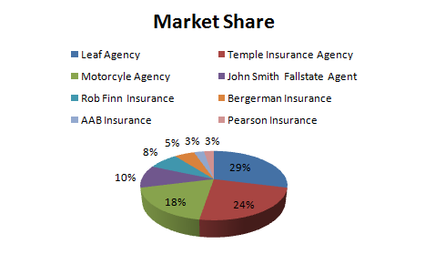
Four of the top eight agencies account for 81% of the market; they are identified (below) for competitive purposes:

Leaf Agency
17 Interstate 45 S Ste 220
Based in College Station, Texas, Leaf Insurance Agency has been operating as an independent agency for 20+ years. This Woodlands office represents 29% of the market, has 11 employees and reported annual revenues in excess of $1.3 million in 2011. The multi line carrier has a good credit rating and offers home and auto policies. Catering primarily to Texas A&M students and alumni, Convenient Insurance plans to partner with this business and offer complementing services to meet life and health needs to these clients.

Temple Insurance Agency
27 Interstate 45 N
This multi line agency with $1.1 million in annual revenues in 2011 represents 24% of the target market. The agency has 9 employees, good credit and has been operating since 1986. The agency is a member of Professional Insurance Agents (‘PIA’). Convenient Insurance will target these customers by relying on its affiliation with Trusted Choice, whose product and service offerings are substantially greater than that of PIA. The company’s website is dated and perhaps attention has been lax in providing the most current insurance offerings as well. Also many long time customers may be unaware of current offerings or their needs may have changed since initial underwriting. Part of Convenient Insurance’s marketing blitz campaign will be targeting these customers and offering a complimentary needs test.

Motorcycle Agency
271 Blueberry Hill Dr Ste 31
This insurance agency caters specifically to motorcycles and competes primarily with Gecko, Regressive, and Fall State. Considered an indirect competitor, Convenient Insurance plans to piggyback off this $875,000 agency by offering complementing products such life and health, and homeowners insurance to these clients.

John Smith Fall State Agent
19 Interstate 45 S Ste 270
This captive agency represents $500,000 or 10% of the local market. The Fall State Agency has 4 employees and excellent credit. Convenient Insurance plans to market to this audience by providing a more diversified selection of offerings.

Market Segments
The chart below identities the largest demographics in the target market:
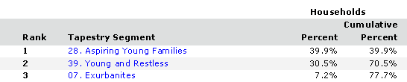

Source: Business Decision Center

The following is a brief description of the target market demographic profile:

Aspiring Young Families:
The median age for this demographic is 30.5 years. The median household income is $52,000. Approximately 60% of this demographic are employed in professional, office management or administrative positions. 58% percent have attended college. 51% of these individuals rent while comparatively 47% own their own homes. This age group spends the majority of their discretionary income on baby products, children’s toys, and home furnishings.

The Young and the Restless
Approximately 2/3 of this age group are under the age of 35. 56% of this age group are single. The median household income is $46,000. Although this income is below the US median income, only 23% of this demographic have children giving them more disposable income. 69% of this community is in the workforce with 73% in this category are women. The young and the restless are busy pursuing their careers and are technologically savvy. They go online to shop, bank, look for jobs and communicate with friends. Purchasing new cars takes precedence.

Exurbanites
Approximately 40% of this demographic group are empty nesters. Half of this group is between the ages of 45-54. The median household income for this age group is $84,000. Because of their life stage, Exurbanites focus on their financial investments. They consult with financial planners regarding their IRA’s. They are interested in long term care and life insurance policies.

Local businesses
In Convenient Insurance’s building alone are over 30 tenants, each with varying insurance needs and opportunities.

Market Tests
Although the target market has independent agencies, the product offerings pale in comparison to the robust offerings and services the Convenient Insurance agency will have. With its affiliation with Trusted Choice, Convenient Insurance has access to 100 carriers compared to their contemporaries with only 50 offerings.

Further by piggybacking off their counterparts, Convenient Insurance will fill unmet needs their counterparts cannot offer. Greg and Maria Bell are currently working with two of their competitors to partner with them for reciprocal sales. The details are being discussed and Convenient Insurance plans to directly market with these businesses when their agency opens for business later this year.

Target Market Segment Strategy
Young and Aspiring Families
Young families have varying insurance needs, from life insurance policies, homeowners / renters insurance and auto insurance. All prospects will be required to complete a complimentary needs based questionnaire to determine what (if any) insurance needs are warranted.

The Young and the Restless
Convenient Insurance will target this group with its competitive auto insurance rates, renters insurance and technology insurance (smart phone devices / computers).

Exurbanites
This target market will need help with evaluating life insurance and long term care. Sometimes known as the ‘sandwich’ group because they still have children in college and aging parents to take care of, this group could also benefit from Medicare supplemental insurance and auto insurance for students.

Local businesses
Small businesses have a myriad of insurance needs, from safe harbor accounts, to key man life insurance policies, umbrella polices and defined benefit and retirement plans for their employees. Convenient Insurance plans to meet each business owner and individually determine their insurance needs and how Convenient Insurance can meet those needs.

Market Needs
The local target market is rife with insurance needs. People at every life stage and customers alike will always have unmet insurance needs.

Market Trends
Like industries across the board, the insurance business is trending to a more technologically efficient environment with apps and internet sites designed for faster turnaround and approval times.

Market Growth
Convenient Insurance plans to grow the agency revenues at an annual rate of 10%. This estimate appears in line when compared to the growth in population of 9.6%.

Positioning
With its strong business ethics, a desire to carefully select insurance products on a need basis and by offering a variety of products to meet every insurance need, Convenient Insurance will hold itself as the premier insurance issuer in The Woodlands.

Marketing Strategy and Implementation
With the opportunity to compete in a $4.7 million market, Convenient Insurance has outlined the following SWOT analysis:

SWOT Analysis
SWOT stands for strengths, weaknesses, opportunities and threats. The following SWOT analysis identifies the internal and external factors that are favorable and unfavorable to Convenient Insurance’s objectives.

Strengths
- The owners with collectively 20+ years experience have demonstrated the proven ability to run, manage and operate an insurance agency.
- Convenient Insurance will be operated by trusted CFPs; No products will be sold unless they have passed the needs test.
- As a Trusted Choice Independent Agency, Convenient Insurance will have over access to 100+ product offerings – enough to cover any insurance need at any life stage.

Weaknesses
- Although the owners have years of industry experience, this is still considered a startup independent office. Start ups have little preferential treatment with vendors and higher overhead and costs.
- Success is measured by policies underwritten; the owners will have time constraints initially due to limited staffing. Over time, they can build their office staff and revenues as well.

Opportunities
- The local Woodlands Market has a wide variety of future opportunities; the target market has diverse demographics with varying needs and a strong local business market to draw from.
- Partnering with or piggybacking off indirect competitors will provide business opportunity and meet unmet needs.

Threats
- Economic downturns, regulations, changes in health care reform, and natural disasters all affect the insurance agency’s ability to keep premiums competitive. The recent drought of the summer, Hurricane Sandy, and the presidential election could potentially adversely impact the industry.
- Technology is key; if Convenient Insurance does not use the latest technological advances, it could quickly slide, losing market share.

Strategy Pyramid

Strategy: Offer a broad range of products and service (in order to capture 2.3% market share).
Tactics: Create awareness that Convenient Insurance is the newest and brightest entrant in the marketplace.
Programs: Marketing blitz both online and in the local community to spread the word.

Strategy: Convenient Insurance will be known for its honesty and integrity as an insurance provider /good citizen.
Tactics: Engage with online services such as Yelp.Com and MerchantCircle.Com – for candid and honest reviews of the products and services provided.
Programs: Actively engage with clients by requesting completion of surveys (both online and over the desk).
Attend customer service training classes.
Sponsor a local school sport - such as a soccer team.

Strategy: Grow customer base.
Tactics: Create an active pipeline.
Programs: Develop reciprocal relationship with complementary vendors; for example partner with the local motorcycle agent and offer free motorcycle safety seminars and offer complementary life insurance evaluations.

Unique Selling Proposition (USP)
Unlike its competitors, Convenient Insurance will strive to be the low pressure, insurance agency of choice. While it is no secret that insurance agencies make their living off commissions, the owners of Convenient Insurance have adopted their personal views and believe that honesty is the best policy.

The owners are taking their clients’ needs to the next level – by mandating each client be required to take a needs based exam to determine which needs are being met and which are not. This higher level of evaluation is unheard of and the owners of Convenient Insurance are honored to be able to provide what they believe is an invaluable service.

Competitive Edge
Convenient Insurance stands head and shoulders above its competitors with its broad product and service offering, need-based selling requirements, high tech interfaces and professionalism and integrity.

Marketing Strategy and Positioning
Convenient Insurance will utilize a product differentiation strategy. Through this type of strategy Convenient Insurance will focus its efforts on holding itself apart from its peers through its broad selection of products and services delivered professionally by Certified Financial Analysts. The agents will only sell services that are needs based. This will eliminate wasteful and (expensive) insurance products and the customer can feel comfortable knowing that his choice to purchase insurance was well worth it. (Unlike their peers, Convenient Insurance will avoid ‘scare’ tactics, which ‘scare’ customers into purchasing excessive, wasteful and expensive insurance products because an overly aggressive agent needed the policy to meet his monthly quota requirements).

Positioning Statement
Convenient Insurance is a full service, independent insurance agency, providing a broad selection of products and services, specifically tailored to the individual needs. All services are based on the individual clients needs and delivered by Certified Financial Planners – all in a low pressure, professional, confidential environment.

Pricing Strategy
Convenient Insurance will utilized competition based pricing – that is pricing based on competitor’s prices – which is standard for the insurance industry.

Promotion and Advertising Strategy
Convenient Insurance will rely on a marketing blitz to get the word out. The owners are members of the local chamber of commerce and will be hosting a grand opening chamber event. Other promotion strategies include:
- Improve its Google rating by utilizing a media/marketing consulting firm to get Convenient Insurance’s name at the top of the major search engines.
- Utilize the marketing agency to assist with telemarketing campaigns.
- Purchase lead lists from local lenders.
- Online Yellow Pages – Utilize this source to obtain business.
- Utilize customer ranking websites such as Yelp.com and Merchantcircle.com.
- Word of mouth – Convenient Insurance loves referrals and will always request referrals.
- Onsite promotions:
- Convenient Insurance will sponsor windshield etching events – where the VIN number of a vehicle is etched into the glass on a car. (This reduces auto theft).
- Collaborate with the local Safety Institute and offer free Baby Seat and Child Safety Seat inspections.
- Drop off donuts / bagels to apartment managers (renters insurance).
- From time to time offer free seminars with a focus on health insurance needs, retirement needs, and financial goals.

Website
The website will have the Convenient Insurance address and business hours as well as links to Trusted Choice carriers, daily blogs, and social media including Facebook (personal lines) and LinkedIn (business lines). Customer will have the ability to view their policies, submit questions, and make payments. Weekly/monthly the website will be updated with current insurance news and media links. Customers will be sent surveys/polls for opportunities for constant contact and open the lines of communication.

Marketing Programs
Initially Convenient Insurance will rely largely on its IIAT’s connections. However, marketing is the primary method to solicit new business and Convenient Insurance will rely on its marketing/media consultants to help with the initial marketing blitz. The local campaign (Chamber of Commerce grand opening) and the online blitz (it is expected that Convenient Insurance website will be linked to the top 40 search engines) will be the ideal way to start off the campaign.

In the local community, Convenient Insurance will host semi-annual sponsored events – such as the VIN etching days and safety seat inspections. In addition their commitment to the community will be evidenced by their corporate sponsorship of a local school sports team.

Sales Strategy
Convenient Insurance has plans to grow revenues 10% in Year 2 and 10% in Year 3. These goals will be met by increases in volume. Additionally volumes are expected to increase with the additions of staff.

The three year hurdle is the minimum requirement prior to being considered for direct appointment. The three year window will demonstrate Convenient Insurance’s proven abilities to run and operate the business. The window will establish a payment and credit history as well. Note: The online business, while appealing, is secondary to the brick and mortar business; the business plan takes a more conservative approach and those incomes have been excluded from the analysis. After the initial 3 years of operations, Convenient Insurance will re-visit this opportunity and possibly include this line item in their financial goals and planning.

Sales Forecast
The financial analysis takes a conservative approach to revenues and assumes revenue and income streams will be derived from 3 primary resources:
- Personal Auto: 12-15% Commission on New Business, 10-15% on Renewals (say 14% premium per $1,000 in coverage),
- Homeowners & Flood Insurance: 12-20% (say 18% premium per $1,000 in coverage)
- All other sources of revenue (health, business insurance, life and renewals) (Say 20% in premium).
This rational is used for two reasons: 1) more conservative and 2) while life insurance, annuities and business lines offer greater premiums, these are the most difficult to attain. The analysis assumes an income growth rate of 10% in Year 2 and 10% in Year 3. The analysis assumes the new agent ramps up revenue, earning 50% by Year 2 and full income streams by Year 3.

Table 5.6.1 Annual Sales Forecast
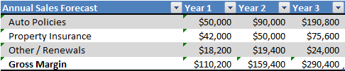

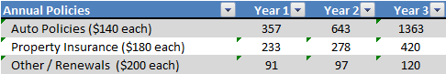

Sales Programs
As insurance agents, the staff at Convenient Insurance works on commissions. Following are approximate commission amounts for each of the different insurance products:
- Personal Auto: 12-15% Commission on New Business, 10-15% on Renewals
- Health Insurance: 15-20% Commission on New Business, 10-20% on Renewals
- Commercial Insurance: 12-20% Commission on New Business, 10-20% on Renewals
- Life Insurance: 80-120% Commission on New Business, 2-10% on Renewals
- Homeowners & Flood Insurance: 12-20%
- Commission on New Business 12-20% on Renewals

Legal
Convenient Insurance has obtained legal advice to make sure that they are not in any violation of any non-compete or any contractually related issues (based on the owners’ history with Mutual of Texas and State Barn). Convenient Insurance was formed as a Limited Liability Company (LLC) in the State of Texas. The entity is wholly owned by its owners Greg and Maria Bell.

Convenient Insurance is registered business with the county and the state. Convenient Insurance has obtained its Federal Identification Number (EIN). Convenient Insurance has also obtained an Insurance Agency License with the state and its Certificate of Good Standing the State.

Milestones
Please refer to the Chart Below:

Table 5.8 Milestones
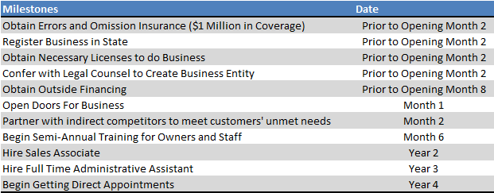

Exit Strategy
Initial debt recourse will first be to Greg and Maria Bell as personal guarantors, the secondary source will be recourse to collateral and tertiary recourse will be the sale and disposal of assets. In the event the company is to be dissolved, all assets will be liquidated. Physical assets will be sold at auction and all policies will rollback to Convenient Insurance’s various independent providers.

Organization and Management
At the heart of Convenient Insurance are its people. In its initial years, Convenient Insurance will operate and run by Greg and Maria Bell.

Organizational Structure
Initially both Greg and Maria will co-manage the agency. Both will actively target the market for new business as well. In Year 1, Convenient Insurance plans to hire a part time bookkeeper to help with the monthly, quarterly and annual filings to their accountant. In Year 2, Convenient Insurance has plans to hire their first agent. The agent will be a CFP candidate as well. Convenient Insurance is committed to its employees and will provide continuing education requirements for the certification. In Year 3, Convenient Insurance has plans to hire a full time administrative position. The administrative position will be more of an office manager role and oversee new and existing bookings, assist in the technical writing of the policies and procedures manual and free up more of the agents’ time to allow them to focus on serving customers. As revenues, grow, staff needs will increase as well.

Management Team
Convenient Insurance will be wholly owned and operated by the husband and wife team of Greg and Maria Bell.

Management Team Gaps
Convenient Insurance does not have an Accounting Department at this time. For now, the company will utilize a part-time bookkeeper and rely on their long term relationship with a reputable local CPA in the preparation of annual tax returns.

Personnel Plan
Following is a summary of the 3 Year Personnel Plan:

Table 6.4 Personnel Plan
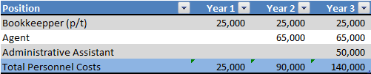

Board of Directors
N/A

Financial Plan
The following is a summary of the financial plan:

- Required Cost of Start-Up
- Profit and Loss
- Cash Flow
- Balance Sheet
- Financial Ratios

Important Assumptions
Income Assumptions
The financial analysis takes a conservative approach to revenues and assumes revenue and income streams will be derived from 3 primary resources:
- Personal Auto: 12-15% Commission on New Business, 10-15% on Renewals (say 14% premium per $1,000 in coverage)
- Homeowners & Flood Insurance: 12-20% (say 18% premium per $1,000 in coverage)
- All other sources of revenue (health, business insurance, life and renewals) (Say 20% in premium)

This rational is used for two reasons: 1) more conservative and 2) while life insurance, annuities and business lines offer greater premiums, these are the most difficult to attain. The analysis assumes an income growth rate of 10% in Year 2 and 10% in Year 3. The analysis assumes the new agent ramps up revenue, earning 50% by Year 2 and full income streams by Year 3.

Expense Assumptions
- During Year 1, the owners will hire a part time bookkeeper. The part time income is expected to be $25,000.
- Halfway through fiscal Year 2, the owners will hire an insurance associate; annualized salary is expected to be $65,000
- During Year 3, the company plans to add a full-time administrative assistant.
- Initially advertising and marketing expense will be high as Convenient Insurance has several 'market blitz' campaigns over the initial years of operations. Over time, it is believed that these expenses will decline, as the book of business builds, the customer base is expanded through word of mouth and referrals, and royalty income streams will replace advertising expenses.

Balance Sheet Assumptions
Convenient Insurance anticipates having sufficient liquidity, have reasonable debt, and a solid equity position.
- The company will have less debt and be better capitalized when compared to peers with similar sized revenues and assets. This is primarily due to the owner's large initial capital infusion of $50,000.
- The company expects to have good liquidity as evidenced by its current ratio of 1.23 by Year 3.
- Convenient Insurance expects to have a relatively low leverage position (56.6% total liabilities at Year 1 compared to 97.4% industry average).
- The company will also be well capitalized. Net worth is expected to be 31.58% of total liabilities and equity at the end of Year 1 compared to industry peers with ratios of 2.6%

Start-Up Costs
Over the last 2 months, the owners have come out of pocket approximately $50,000 covering the sunk costs associate with establishing an office.

Start up expenses are $ 27,300 and primarily in the form of working capital requirements totally $20,000.

Start Up assets are comprised primarily of funds available to start the book of business in the amount of $70,000. The owners will use these funds to help seed or start the new business. Other starts up assets include computer hardware, software and redundancy systems, and office furnishings and fixtures.

Table 7.2 Start-Up Costs
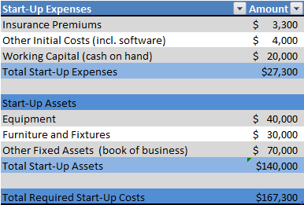

Source and Use of Funds
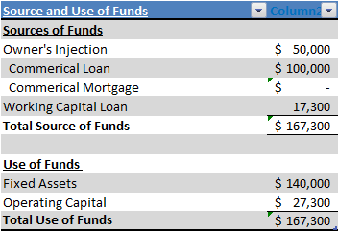

Sources: The owners of Convenient Insurance have spent well over $50,000 to date for start up operations. Additional funding is expected to come from $100,000 commercial loan and a $17,300 working capital loan.

The owners’ equity contribution is substantially higher than industry average when compared to peers. This higher than average equity injection provides some additional cushion and results in a lower LTV (loan to value) ratio for its lenders.

Break-Even Analysis

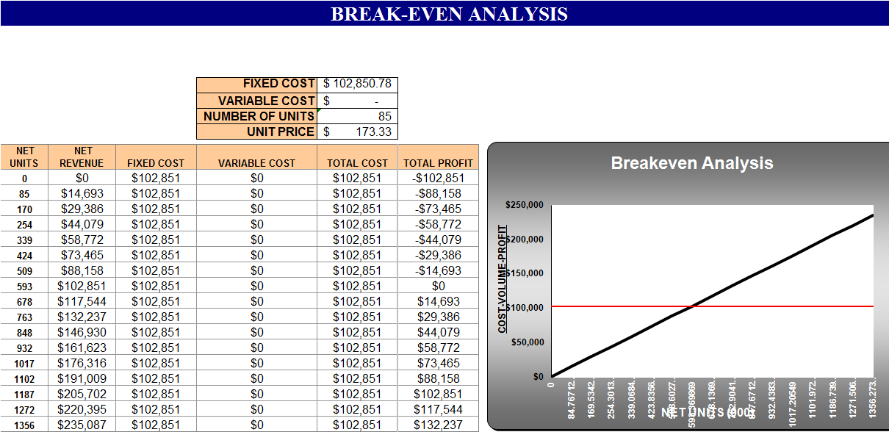

Note: There are no variable costs (cost of goods sold) with this type of entity (service business).

Projections

Projected Profit and Loss
The estimated profit and loss for Convenient Insurance are as follows:

Table 7.5.1 Pro Forma Profit and Loss
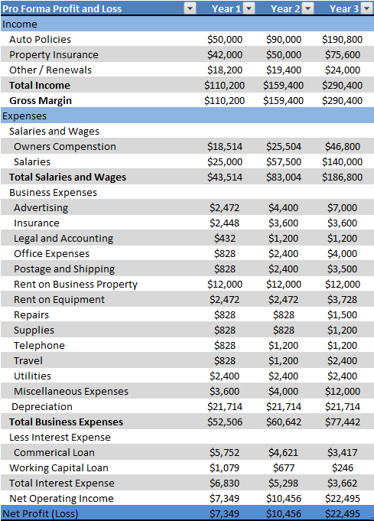

Projected Cash Flow

The statement of cash flow shows the incoming and outgoing cash of the business.

Table 7.5.2 Pro Forma Cash Flow

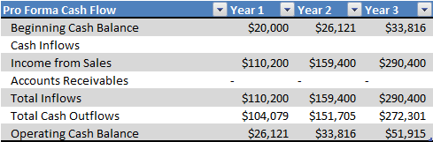

Projected Balance Sheet
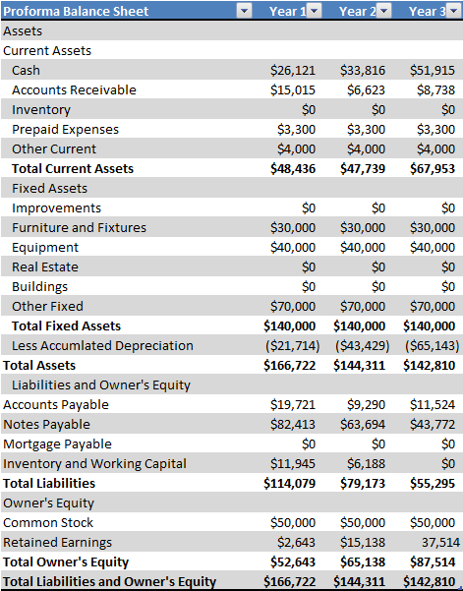

Business Ratios
The analysis is based on NAICS (North American Industry Classification System) 524210 Insurance Agencies and Brokerages.

Table 7.6 Ratio Analysis
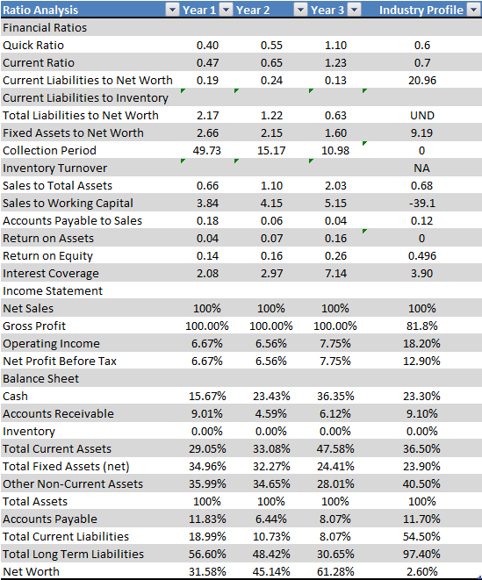

This business plan template can be downloaded at:
http://www.fastbusinessplans.com/business-plan-template.html

Free sample business plans are available at:
http://www.fastbusinessplans.com/sample-business-plans.html.

Many articles to assist in guiding you through the writing of your business plan are available at:
http://www.fastbusinessplans.com/business-plan-guide.html

