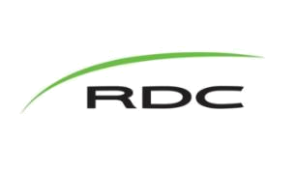

RDC Career Services for students

References

What is a Reference?

References are people who an employer could phone and find out what kind of worker you are, or the type of person you are. When you get an interview take along a list of 2-3 references for the employer, that is typed, printed and has your contact information placed at the top. Always use their work address and phone number, or where they can be reached during the day. Also ask your references what they would say to an employer about you!

Give your reference a call when you have submitted their information to a potential employer.

Follow up with your references to see which employers called and what they were asked.

Reference Page (Sample)

References
Your Name

Address (include postal code)
Telephone Number

Name of Reference

Their Position, Title
The Company Name
Phone Number

Name of Reference

Their Position, Title
The Company Name
Phone Number

Name of Reference

Their Position, Title
The Company Name

Phone Number

Counselling & Career Centre | Red Deer College | 100 College Boulevard | Red Deer | AB | Canada | T4N 5H5 | www.rdc.ab.ca

