Header should be
the same as the
header on your

resume!

Personalized LinkedIn
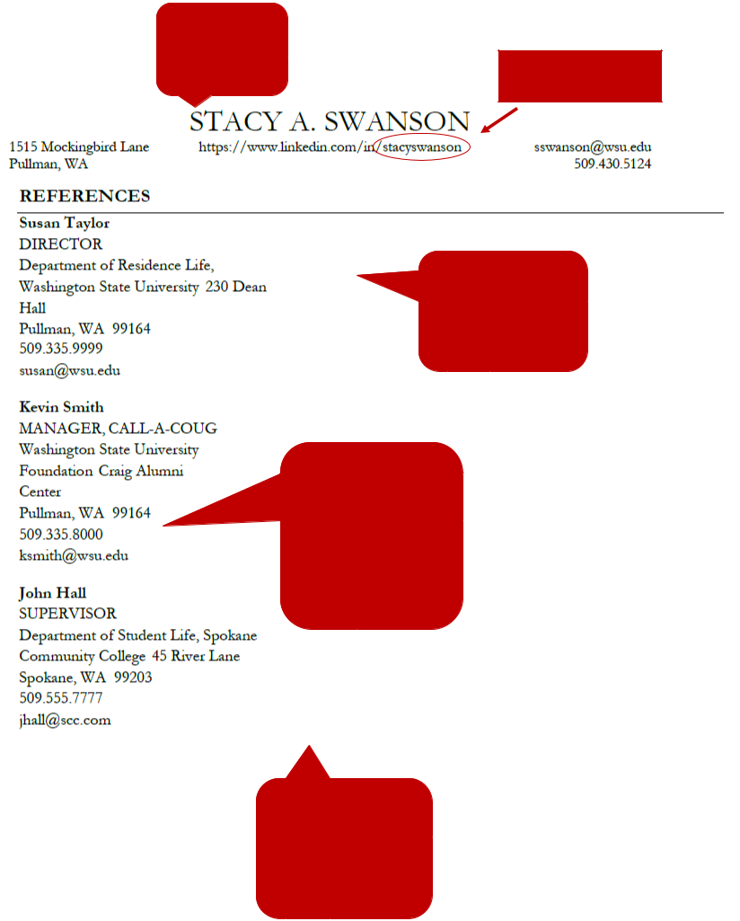
URL

Use the same

formatting from
resume (font, style of
section headings and

titles, etc.)

Each reference should
have:

Name
Reference’s Job Title
Company/Organization
Mailing Address
Phone Number

Email Address

Reference pages should
have 3-5 professional
references and should
always be on a separate
page (not on your

resume).

