

PROFESSIONAL

RESUMEGUIDE

STUDENT, GRADUATE & CO-OP EMPLOYMENT CENTRE

 PROFESSIONAL RESUME GUIDE

Table of Contents

Purpose of the Resume 1

Types of Resumes 1

Formatting and Creating a Professional Image 5

Resume Sections 5

Optional Sections on a Resume 10

Continuous Updating of Resume 12

References 13
PROFESSIONAL RESUME GUIDE


Purpose of the Resume

Writing a professional resume has one specific purpose: to win an interview.

A resume is an advertisement, nothing more, nothing less. A great resume does not just tell employers what you have done, but, as all advertisements should, it serves to make the assertion that: If

you buy this product, you will get these specific, direct benefits. It convinces the employer that you have what it takes to be successful in this new position or career based on your skills, education, or experience.

Your job is to make it as easy as possible for the employer to quickly find the relevant information they are looking for. By clearly articulating your relevant skills and proof of those skills, along with making the resume visually appealing, it should stimulate interest in meeting you/learning more about you.

Types of Resumes

The three standard types of resumes are Chronological, Functional, and Combination.

Chronological Resume

The chronological resume places your skills/accomplishments within the context of your employment history or volunteer experience and demonstrates your career progress. Most employers prefer the chronological format for this reason – it is easy to see where you have achieved what you have stated. To write a resume in chronological format:

Present your employment history in reverse chronological order (most recent position first)

Note each position held including job title, company name, location, and dates of employment

You can include your Education section prior to your Employment History/Professional Experience section as your current education is extremely relevant; once you have gained professional experience in your field of interest, you can reverse the order of these sections

Include a company description for companies that are not well-known or are international; write the company description directly below the company name (use italics to make it stand out)

Include bullet points written as accomplishment statements (see page 9) for each position held

Attention can be drawn to key relevant skills by including a Highlights of Qualifications/Profile section at the very top with key skills + proof to support those key skills (see page 7)

1
PROFESSIONAL RESUME GUIDE

Sample Chronological Resume:
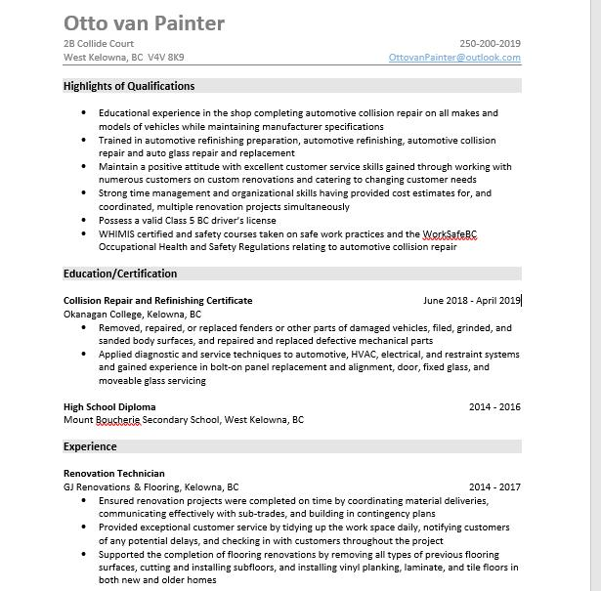

2
PROFESSIONAL RESUME GUIDE

Functional Resume

The functional resume places your skills/accomplishments under skill headings. Examples from multiple positions or educational experiences may be included under one skill heading. This style of resume can be effective for individuals with too many positions to list on the resume, or for individuals who are early in their career, have gaps in employment, or are making a career switch; however, because this style of resume makes it difficult for the reader to identify where the achievements/examples are coming from, it is not the preferred choice by employers.

Sample Functional Resume:
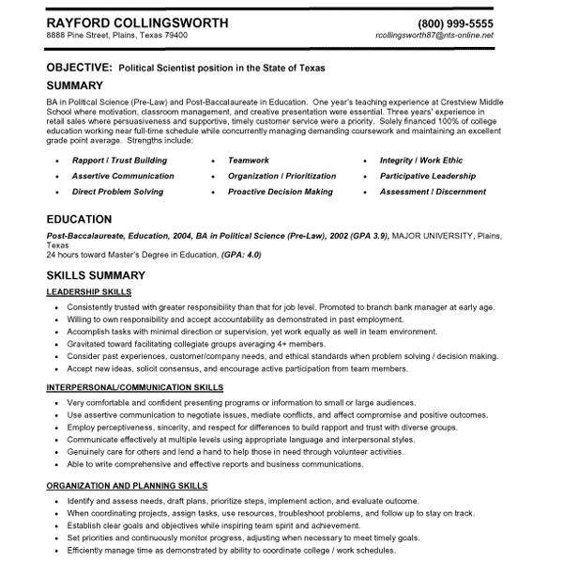

3
PROFESSIONAL RESUME GUIDE

Combination Resume

The combination resume highlights the skills and expertise you have acquired over your entire career by including examples under skill headings. Under those skill headings, the Professional Experience is listed in reverse chronological format; however, only company names, position titles, and date ranges are listed, rather than including accomplishment statement bullet points under each position held. This style of resume can be beneficial when wanting to draw attention to specific skills; however, typically, employers want to understand what you accomplished and where and when you accomplished it.

Sample Combination Resume:
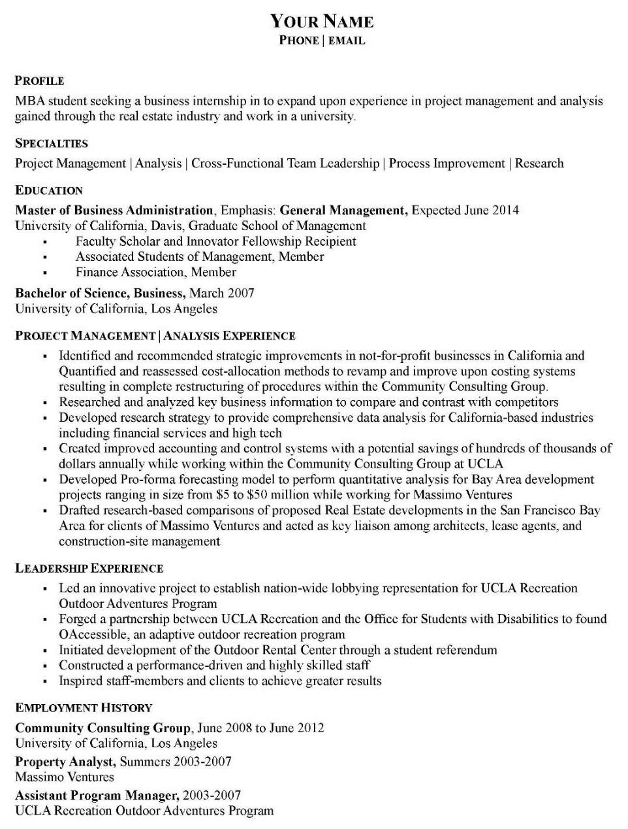

4
PROFESSIONAL RESUME GUIDE

This guide will focus on how to create the most preferred type of resume, the Chronological resume.

Formatting and Creating a Professional Image
Use a standard font (Arial 10, Times New Roman 11, or Calibri 11)

Ensure dates are aligned with the right margin (set right tabs) and dashes are the same size and have the same spacing throughout (i.e. 2009 – 2011)

Ensure your bullet points are regular circle bullets (not overly large) and are all aligned and the text in the bulleted sections is indented and aligned

Include page numbers within the footer field on both pages (if on two pages)

Ensure consistent formatting throughout (headings and text should be properly aligned) Ensure there are no typing, spelling or grammar mistakes

Do not include personal information such as marital status, age, religious affiliations, etc. and do not include your photo

Your resume should be 1 to 2 pages (maximum) in length

If printing your resume, use the same type of paper for both your resume and cover letter; preferably light colored, plain high quality paper

Resume Sections

Header

The header contains your name and contact information within the Header field of your Word document. Think of your header as a form of personal branding, so feel free to be a little creative; however, refrain from using logos, pictures, etc., unless you have an eye for design or are applying for a position where it might be relevant to demonstrate this skill (i.e. graphic design, marketing).

Ensure your name stands out and your contact information is clear Include either your mailing address or just your city and province

Include only one phone number, professional email address, and your LinkedIn profile link (optional)

Ensure the spacing, font size, and style of header is consistent on both pages of your resume, on your cover letter, and at the top of a references page

Header Examples:
 | LESLIE SMITH
1234 Somewhere Street | 250-123-4567
Kelowna, BC, V4V 1K9 | leslie.smith@sample.com


5
PROFESSIONAL RESUME GUIDE

Profile or Highlights of Qualifications Section


This is one of the most important sections on a resume. You can customize this section so that the key skills and accomplishments you have that are relevant to the job you are applying for are summarized here in no more than 5 or 6 bullet points. Differentiate yourself by highlighting what is unique about you. If you are stating that you possess a particular relevant skill, provide a SPECIFIC example as proof.

When drafting this section, think about your career interests and the skills that would be most sought after in a candidate. Use job postings that are appealing to you to identify trends. Next, think about your experiences, your education, and your community involvement. What are some of the highlights or achievements that stand out to you? Use those as proof to support key skills. As a starting point, try to include skills that are found on multiple job postings of interest. Once you are ready to apply for a specific position, you can further tailor this section to the actual job posting you are applying for.


This summary should allow the reader to get an overall sense of who you are. You can imagine with companies receiving thousands of applications, they tend to get the same skills listed by students. Think outside the box – be sure to include skills that reflect the company values. By reading only this section, the employer should understand your main strengths relevant to the position you’re applying for and be intrigued by your main accomplishments (again that might be relevant to the position of interest).

Things you may include in this section:

If you have experience/education relevant to the position of interest, write the first bullet point as a summary of that relevant experience/education

The next few bullet points should each consist of one (or two related skills) with proof (think of an accomplishment/achievement you are proud of) to support that key relevant skill

Ensure the skills you have chosen are key skills that would be required for the position of interest and are a reflection of what comes naturally to you in terms of strengths

You can include a final bullet point(s) on computer application proficiency, languages, and/or specific certifications (if required for the position of interest)

**Ensure your bullet points are unique to you and could not be written by another person

6
PROFESSIONAL RESUME GUIDE

Highlights of Qualifications Example:


HIGHLIGHTS OF QUALIFICATIONS

Two years of experience as a Marketing Assistant developing promotional campaigns, optimizing

and updating company websites and landing pages, and creating monthly newsletters
Strong teamwork skills having collaborated with a team of six classmates to create a marketing plan

for a local start-up; received the top grade in the class for this term project
Excellent leadership skills demonstrated through leading a team of 15 volunteers to raise $10,000

for Canuck Place Children’s Hospice at a large fundraising dinner and auction event
Ability to communicate effectively evidenced through interacting with hundreds of customers as a

Server at Earls and being promoted to Head Server based on the superb customer service provided Proficient in Photoshop and Microsoft Office Suite (Word, Excel, Outlook, PowerPoint)

Alternatively, you can this section in non-bulleted format if you choose.

Profile Example:

PROFILE

Food Service Worker with 6+ years of experience serving and preparing food in a variety of different food establishments. Provide excellent customer service, and possess extensive knowledge of wines, entrees, restaurant equipment, and POS terminals. Sales and marketing experience gained through providing both menu update feedback to senior leadership and providing customers a holistic understanding of restaurant offerings.

Education Section

Your education should be listed in reverse chronological order (most recent first).


Follow the formatting provided in the example below (in terms of the bolding, spacing, and alignment of dates with the right margin).

You can include the expected completion (month and year) either by including it within the date range (i.e. September 2018 – Expected Graduation: December 2020) or by including it within a bullet point.

You can include, as a bullet point, your GPA if it is strong or being on

the Dean’s list, if applicable. You can include bullet points on relevant projects, awards received as part of your educational program, or relevant coursework you would like to draw attention to. Term projects and/or practical lab experience examples can be an effective way to demonstrate relevant experience and skills, especially if you haven’t had professional work experience in the field of interest.

7
PROFESSIONAL RESUME GUIDE

Education Section Example:

EDUCATION

Water Engineering Technology Diploma Sept. 2018 – Expected Completion: Dec. 2020
Okanagan College, Kelowna, BC
Educational foundation in the fundamentals of water treatment inclusive of water resources,

water treatment, fluid mechanics, laboratory analysis, and hydrology

Practical experience consisted of calibrating equipment, preparing/testing water samples, analyzing chlorine decay, conducting turbidity and coliform tests, and learning coagulation and

filtration techniques
Current GPA: 90%: Dean’s List for Fall 2018 Semester

Secondary School Diploma

George Elliot Secondary School (GESS), Lake Country, BC

June 2018

Professional Experience Section


List your relevant professional experience in reverse chronological order (most recent first). If experience is in the past, use past tense; if currently working in the position, use present tense for actions you continuously perform.

Ensure the formatting of this section is consistent (i.e. the company name first, followed by location (City, Province), and then the years lined up with the right margin and your position title underneath (see the example below). The same format should also be used in your Volunteer Experience section.

For companies that are not well-known or are international, you can include a brief company description. There is no need to do this for well-known companies.

Ensure each bullet point listed is written in the form of an accomplishment statement (starting with a strong accomplishment verb (i.e. Improved, Maximized, Ensured, Saved, Decreased, etc.) followed by ‘by/through,’ followed by action verbs with ‘ing’ endings to explain how you accomplished what you did. The action verbs are what demonstrate your transferable skills. By writing in this format, you ensure that the company you are applying for understands what you have accomplished in the past and how you might benefit their organization in the future. It also helps them understand the scope of your experience (quantify when possible) and your level of involvement. Use the T-chart you initially created to help you (see the Job Application Preparation Guide on our website).

When creating accomplishment bullets, keep in mind that companies want to see results, so, as much as possible, start your bullet point with the result:

i.e. Increased awareness of brand by 20% through conducting several focus groups and tailoring the promotional message to the target audience

8

PROFESSIONAL RESUME GUIDE

Accomplishment Statement Formula:

RESULT: Accomplishment + by/through + Transferable Skill* (use action verbs and verb with result (quantify quantify the scope of what was when possible) accomplished)

If you cannot identify a quantitative result, think about what the positive impact or benefit to the company was.

i.e. Built and maintained positive relationships with customers by identifying their unique needs and providing individualized information about products.

ACCOMPLISHMENT VERB EXAMPLES:

Attained | Decreased | Ensured | Minimized | Saved
Exceeded | Resolved | Reduced | Maximized | Retained
Improved | Surpassed | Increased | Eliminated | Removed

Accomplishments don’t need to be monumental to show an employer how you can add value. Think of how you made things better in even a minor way. Rather than only listing your duties in a position, an accomplishment statement describes how that helped the organization. For example, ‘compiled feedback’ is a duty, whereas ‘Supported a website design launch by compiling feedback from multiple departments’ is an accomplishment.

ACCOMPLISHMENT STATEMENT EXAMPLES

Accomplishment verb with | by/through | Transferable Skill (quantify the scope
result (quantify when possible) |  | of what was accomplished)
Improved customer feedback | by | implementing a training program for 10 new
 |  | Customer Service Representatives and ensuring
 |  | clients consistently received timely and
 |  | complete information.
Increased sales by 18% | through | developing and implementing divisional store
 |  | merchandising plans.
Promoted to Customer Service | by | delivering customer education on the
Supervisor in three months |  | company’s services and sharing best practices
 |  | with colleagues.

*The order of the accomplishment statement can be reversed as long as all elements of formula are included.

If your resume is on two pages, ensure you write a section heading at the top of page 2 (i.e.

PROFESSIONAL EXPERIENCE (continued)).

9
PROFESSIONAL RESUME GUIDE

Professional Experience Section Example:

PROFESSIONAL EXPERIENCE

Company Name, City, Province, Country
Descriptive sentence (if required) explaining what the company does.

year – year

Marketing Assistant

Assisted with a new and improved website design launch by compiling feedback on site mapping and product descriptions during in-production testing

Ensured an up-to-date, consistent, and functional store locator by contacting retailers to verify

retail locations and collaborating with website developers to identify bugs in the locator coding Contributed to increased sales during yearly trade shows through preparing products for

promotion sampling and providing detailed and accurate product information to inquiring

customers
Improved office workflow by accurately preparing product orders for weekly shipment deadlines

Optional Sections on a Resume

There are other ways you can include experience and transferable skills other than just in your Professional Experience section. Be sure to include any academic projects, community involvement/volunteer experience, additional training/certifications, memberships, case competitions, awards and scholarships (if not included under the Education section), musical achievements, etc. that would be relevant to the types of positions you are interested in. Follow the format provided in the examples below. These sections can be included below your Education and Experience sections.

Volunteer Experience


Include volunteer experience you have done or are currently doing that can demonstrate key competencies such as initiative, teamwork, time management, organizational ability, and leadership. Don’t underestimate the importance of this section just because these are unpaid experiences. Companies like to see community-minded individuals. Include time commitment (i.e. average hours per week or days per month).

Write bullet points in accomplishment statement format just as you would do in the Experience section (i.e. think about results). You should convey the result and how you did it, which will demonstrate your transferable skills.

10

PROFESSIONAL RESUME GUIDE

Volunteer Experience Section Example:

VOLUNTEER EXPERIENCE

Okanagan Boys and Girls Club (OBGC), Kelowna, BC 2017 – Present
Volunteer Youth Program Coordinator (14 hours/week)

Support the Youth Centre Drop-In Program by coordinating recreational activities and collaborating with a team of five other volunteers to prepare meals

Academic Projects

If you worked on a term project or other significant project, you can include details of the project either as a bullet point within your Education section or within a separate section named Academic Projects. Think about the experience gained or the skills required to successfully complete that project and try to include detail on what your role was. This can be especially beneficial if you do not have professional experience relevant to the types of positions you are applying for.

Academic Projects Section Example:

ACADEMIC PROJECTS

Okanagan College, Kelowna, BC
Bachelor of Computer Information Systems
Collaborated with a team of two to create a car racing game with a visually appealing user

interface using JavaFX; received a project grade of 100%

Acted as School Representative for Java Cup 2018 (an inter-collegiate Computer Programming Competition)

Additional Training/Certifications

If you have additional training or certifications that might be an asset in the position, you can include them in an Additional Training/Certifications section. If there is specific training or certification that you possess that is required for the position of interest, include it within your Highlights of Qualifications section rather than including it within this section towards the end of your resume, otherwise it may get missed by the reader.

Additional Training/Certifications Example:

ADDITIONAL TRAINING/CERTIFICATIONS
CPR B with AED Certificate, St. John Ambulance, Kelowna, BC | 2018
Workplace Hazardous Materials Information System (WHMIS) Certificate, Kelowna, BC | 2019
 | 11

PROFESSIONAL RESUME GUIDE


Interests

If your interests are unique and might set you apart from another candidate, you can include them. These can be valuable if they convey your passion, dedication, teamwork ability, or leadership skills.

Interest Section Example:

INTERESTS
Junior Boys Volleyball, Saskatoon, Saskatchewan | 2015 – 2016
Assistant Coach
Contributed to improving players’ skill by designing and implementing a practice schedule;

Won City Championships in 2016

Royal Conservatory of Music, Kelowna, BC
Grade 10 Certificate, Guitar, First Class Honors with Distinction | 2015

Continuous Updating of Resume

There will be times in your life when you are either in school or employed and not actively job searching. It is just as important during those times that you ensure your resume is up to date. Here are some tips to ensure you have what you need when it is time to start your job search once again:

Create a master list of your accomplishments (quantifying/qualifying when possible) throughout your time of employment; you may remember well what you have accomplished

while you’re in the role, but once time passes, you may forget

Write down the projects that you work on as part of your studies (including details of what your role was, whether it was a team project, the size of the team, and what you achieved); you may

remember the project well while you’re completing it, but once time passes, you may forget

If you are a Co-op student, the Work Term Report that you create for each work term will be extremely valuable to you when it comes to applying for a position; you could submit your report as part of your application, bring your report to a job interview, or pull accomplishments from the report to include in your resume or cover letter

12
PROFESSIONAL RESUME GUIDE

References

Rather than include references on the resume document itself, create a separate document (saved as a separate file) that can either be included with the application (if requested by the employer) or simply ready to bring to an interview.

Be sure to ask permission in advance before using someone as a reference. It is helpful if you provide the job posting as well as your cover letter and resume to your reference so that he/she may review those prior to the potential phone call from the employer. That way, he/she will be able to speak to your relevant skills/abilities based on what the employer is looking for.

Ideally, include three references who can speak to your ability to carry out the job for which you are applying. These references could come from your professional experience or volunteer experience. If necessary, a professor can be used as a reference as long as he/she knows you well enough and can speak to your work ethic/skills.

References Example:

 | LESLIE SMITH
1234 Somewhere Street | 250-123-4567
Kelowna, BC, V4V 1K9 | leslie.smith@sample.com

REFERENCES

Preet Dhial
Manager, Customer Experience
ABC Company
5566 Name Street
Kelowna, BC, V4E 4K9
250-111-2222
pdhial@email.com

Irina Grenville

Youth Coordinator Supervisor
XYZ Company
19845 Somewhere Boulevard
Kelowna, BC, V3O 4C9
250-333-4444
igrenville@sample.com

Jacob Aldegund
General Manager

- Company 3490 Thisway Court

Lake Country, BC, V4K 9L2 250-111-5555 jacobaldegund@email.com

13

