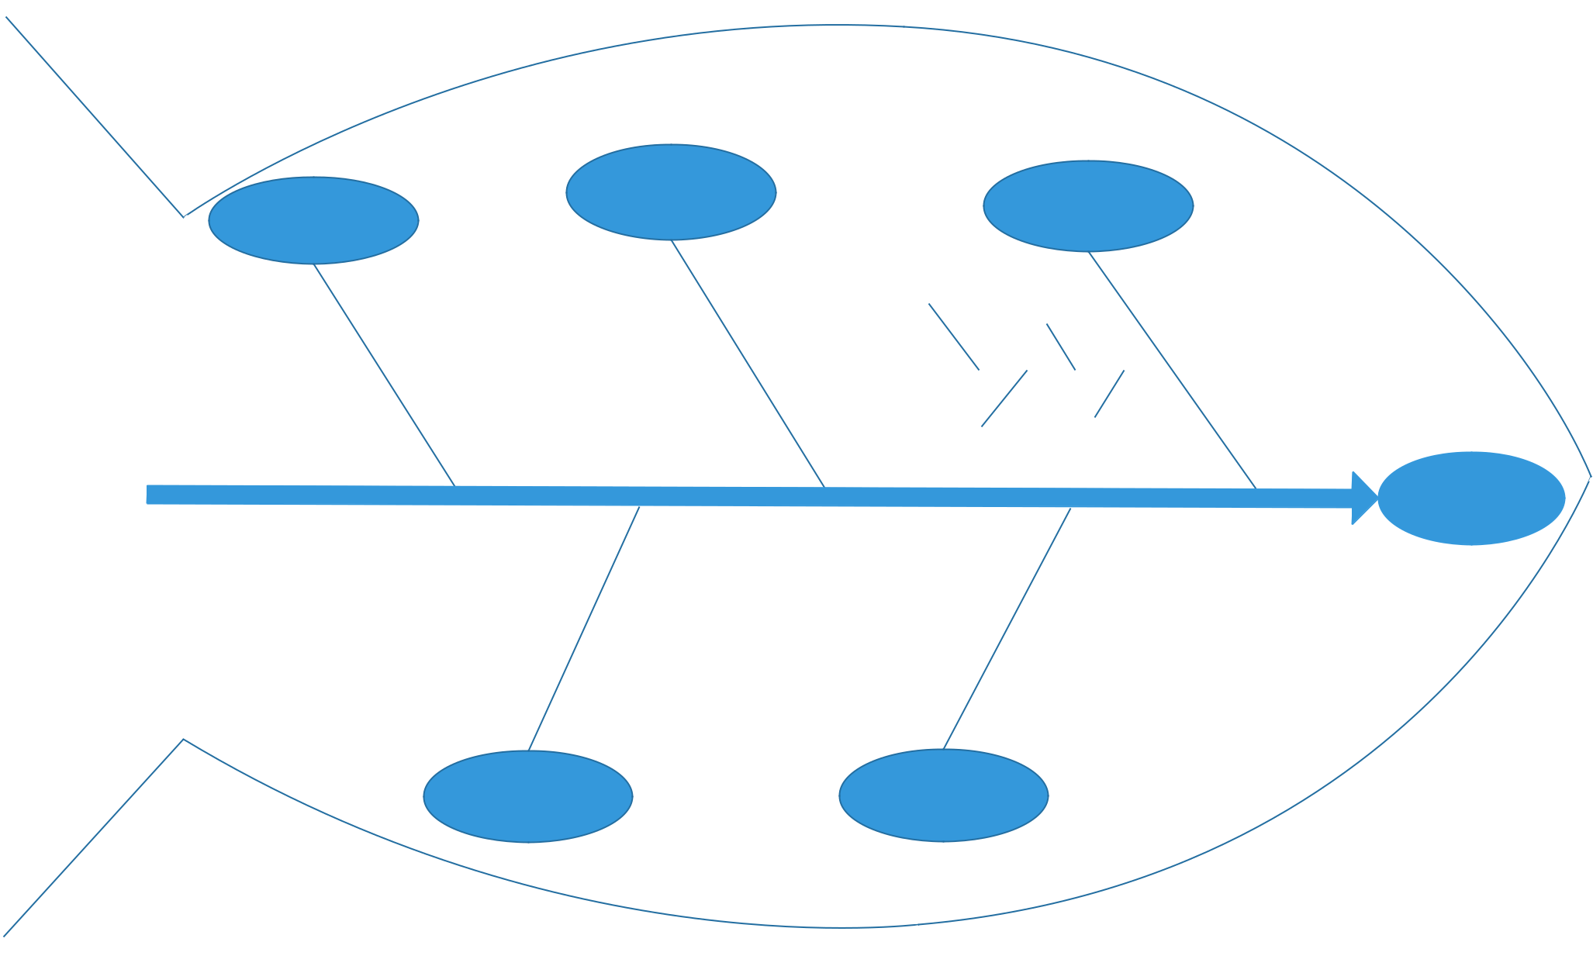

 |  |  |  |  |  |  |  |  |  |  |  |  |  |  |  |  | Learning
 | Teaching & |  |  |  |  |  |  |  |  |  |  |  |  |  | Strategies |  |  |  |  |  |  |  |  |  |  |  |  |  |  |  |  |  |  | Learning Ability
 | Instruction
 |  |  |  |  |  |  |  |  |  |  |  |  |  |  |  |  |  |  |  |  |  |  |  |  |  |  | Definition |  |  |  |  |  |  |  |  |  |  |  |  |  |  | Basic Skills
Teachers
 |  |  |  |  |  |  |  |  | Lack of Strategies |  |  |  |  |  |  |  |  |  |  |  |  |  |  |  |  |  |  |  |  |  |  |  | Vocabulary
 |  |  |  |  |  |  |  |  |  |  |  |  |  |  |  |  |  |  |  |  |  |  |  |  |  | Basic
 | Parents
 |  |  |  |  |  |  |  |  |  |  |  |  |  |  |  |  |  |  |  |  |  |  |  |  |  | Knowledge
 | Friends |  |  |  |  |  |  |  |  |  | Effective Strategies |  |  |  |  |  |  |  |  |  |  |  |  |  |  |  |  |  | Concepts ^{Theorem} |  |  |  |  |  |  |  |  |  |  |  |  |  |  | Comprehensive Skills
 |  |  |  |  |  |  |  |  |  |  |  |  |  |  |  |  |  |  |  |  |  |  |  |  |  |  |  |  |  |  |  |  |  |  |  |  |  |  |  |  |  |  |  |  | Academic
 |  |  |  |  |  |  |  |  |  |  |  |  |  |  |  |  |  |  |  |  |  |  |  |  |  |  |  |  |  |  |  |  |  |  |  |  |  |  |  |  |  |  |  |  | Record
 |  |  |  |  |  |  |  |  | Outsight |  |  |  |  |  |  |  |  |  |  |  |  |  |  |  |  | Learning Interests |  |  |  |  |  |  |  |  |  |  |  |  |  |  |  |  |  |  | Record
 |  |  |  |  |  | Thinking Ability |  |  |  |  |  |  |  |  |  |  |  |  | Memory |  |  |  |  |  |  | Study Habits |  |  |  |  |  |  |  |  |  |  |  |  | EQ (Emotional Quotient)
 |  |  |  |  |  |  |  |  |  |  |  |  |  |  |  |  |  |  |  |  |  |  |  |  |  |  |  |  |  |  |  |  |  |  |  | Sense of Responsibility
 |  |  |  |  |  |  |  |  |  |  |  |  |  |  |  |  | Imagination
 |  |  |  |  |  |  |  |  |  |  |  |  |  |  |  |  |  | Ability |  |  |  |  | Character &
 |  |  |  |  |  |  |  |  |  |  |  |  |  |  |  |  |  |  |  |  |  |  |  | Will Power
 |  |  |  |  |  |  |  |  | Intelligence |  |  |  |  |  |  |  |  |  |  |  |  |  |  |  |  | Non-intelligence
 |  |  |  |  |  |  |  |  | Factors |  |  |  |  |  |  |  |  |  |  |  |  |  |  |  |  |  | Factors

