OFFICE CLEANING SCHEDULE

Facility Cleaning

Occurs Daily by:
Occurs Weekly
by:
Solutions Used:
Includes: | MON | TUE | WED THRU | FRI | SAT | SUN
Floors
Exam Tables
Restrooms
Furniture
Dusting entire
office

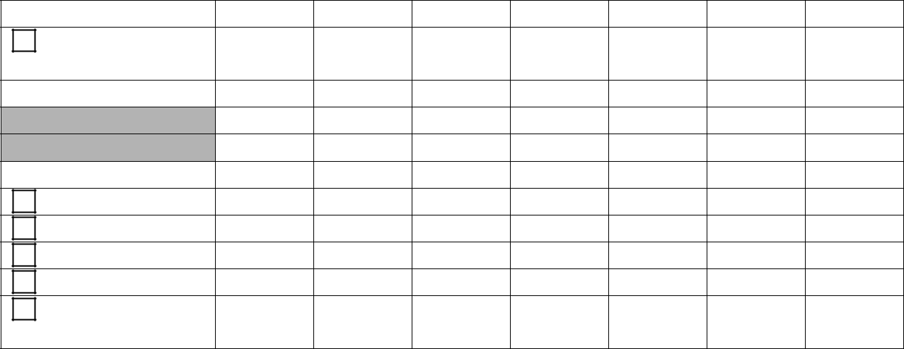

Exam Room/Patient Restroom(if in office) Daily Cleaning:

Solution Used:

End of Day by:

As needed during day by

Biohazardous Spill during Office Hours

Assigned Person:___________________________________

Uses only the Personnel Protection Kit(Spill or Infection control kit) Places materials in Red Biohazard bag and places in the biohazard storage container.

Revised 4/1/2010

OFFICE CLEANING SCHEDULE

Facility Cleaning

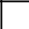 Occurs Daily by:

Occurs Weekly by:

Solutions Used:

2Xdaily - Weekly - Daily

Floors

Exam Tables
Restrooms

Furniture
Dusting office
Exam Room/Patient Restroom(if in office) Daily Cleaning:

Solution Used:

End of Day by:

As needed during day by

Biohazardous Spill during Office Hours

Assigned Person:___________________________________

Uses only the Personnel Protection Kit(Spill or Infection control kit) Places materials in Red Biohazard bag and places in the biohazard storage container.

Revised 4/1/2010

