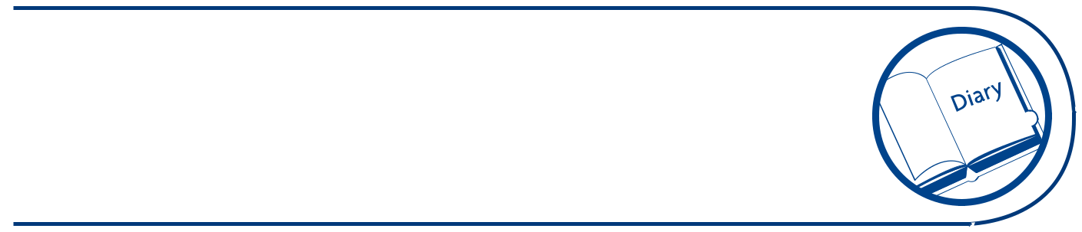
Cleaning schedule


Fill in details of all the items you clean

Item | Frequency of cleaning |  |  |  |  |  | Precautions | Method of cleaning
 |  |  |  |  |  |  | e.g. wear gloves
 |  | Every shift |  |  |  |  | or goggles
 | After use | Every shift | Daily | Weekly |  | Other
Work | x |  |  |  |  |  | Wear gloves | 1. Remove any obvious food and dirt.
surface |  |  |  |  |  |  |  | 2. | Wash the surface with hot soapy water (detergent diluted
surface |  |  |  |  |  |  |  |  | according to manufacturer’s instructions) to remove grease and
 |  |  |  |  |  |  |  |  | any other food and dirt.
 |  |  |  |  |  |  |  | 3. | Rinse with clean water to remove the detergent and loosened
 |  |  |  |  |  |  |  |  | food and dirt.
 |  |  |  |  |  |  |  | 4. | Apply a disinfectant. Make sure you leave it on for the contact
 |  |  |  |  |  |  |  |  | time recommended by the manufacturer.
 |  |  |  |  |  |  |  | 5. | Rinse with clean water to remove the disinfectant.
 |  |  |  |  |  |  |  | 6. | Leave to dry naturally or use a clean disposable cloth.

Cleaning schedule


Fill in details of all the items you clean

Item | Frequency of cleaning |  |  |  |  |  | Precautions | Method of cleaning
 |  |  |  |  |  |  | e.g. wear gloves
 |  | Every shift |  |  |  |  | or goggles
 | After use | Every shift | Daily | Weekly |  | Other

