Where To Start: A Decision Tree
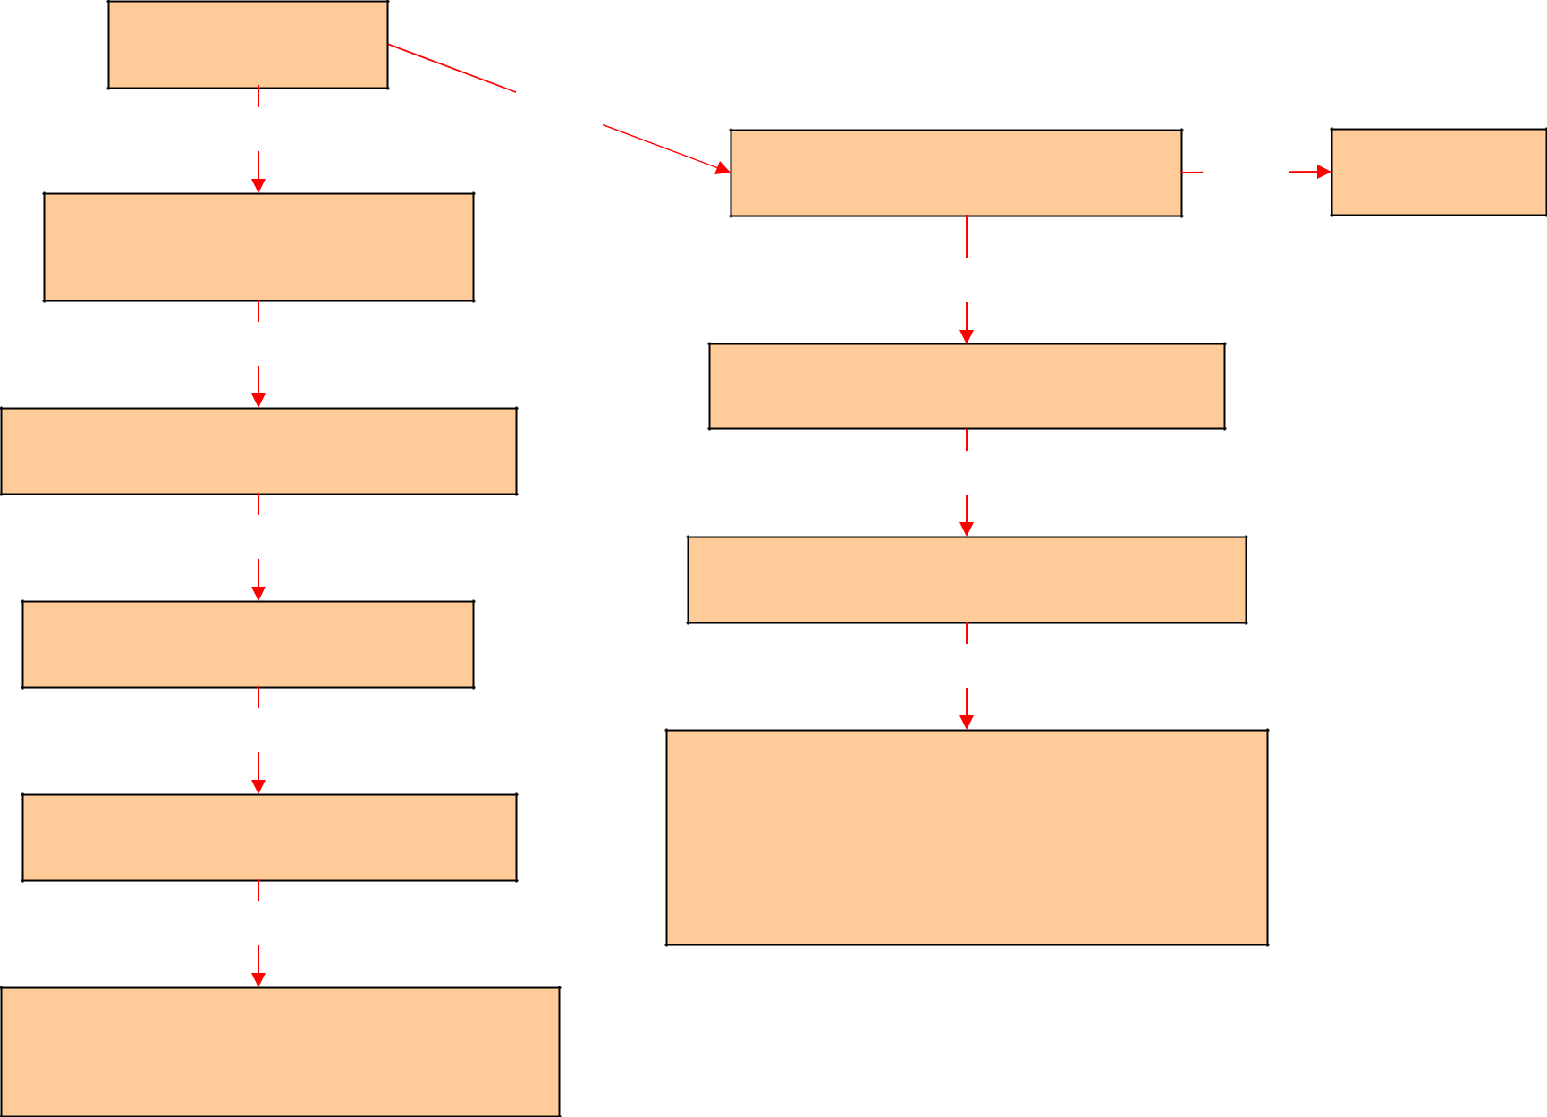

Start here:

Is your project new?

No

Yes

Is your project an activity that requires | No
review? See What Requires Review | No
No review

required

Do you need to make changes to your CPHS approved project?

See Types of Review - Amendment

No

Do you need your project to be reapproved?

See Types of Review – Continuing Review

No

Is your project complete?

See Types of Review – Study Closure

No

Has there been a protocol deviation?

See Types of Review – Protocol Deviation

No

Has there been an unexpected problem that is related or possibly related to subject participation in the research? See Types of Review – Unanticipated Problems & Adverse Events

Yes

Does your project qualify for Exempt Status?

See Types of Review - New Exempt

No

Does your project qualify for Expedited Review?

See Types of Review - New Non-Exempt

No

Projects that do not qualify for Exempt Status or Expedited Review must be reviewed by the Full (convened) Committee. Full Committee review takes place at the monthly meetings of two committees.

See Types of Review - New Non-Exempt

See also Committee Directory & Meeting Calendars

Questions? Contact OPHS:

Phone (510) 642-7461 or Email ophs@berkeley.edu

CPHS/OPHS Website: http://cphs.berkeley.edu

