Name _____________________________________ Assessment (1 page)

Decision Tree Template
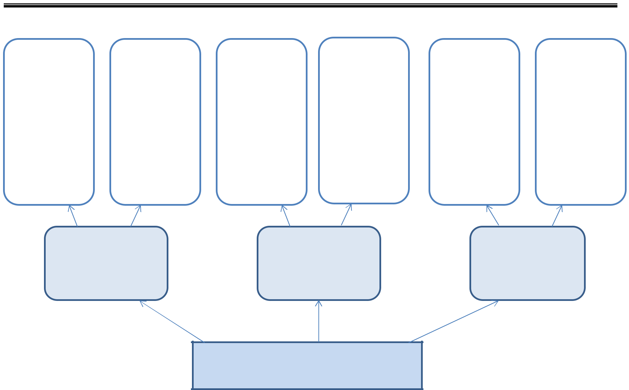

Positives Negatives Positives Negatives Positives Negatives

Option 1: Option 2: Option 3:

What should Emperor Shōmu have done?

© 2014 Program for Teaching East Asia, University of Colorado Building Tōdai-ji

Name _____________________________________ Assessment (1 page)

Tōdai-ji Decision Tree Rubric

1=not present; 2=minimally present; 3=adequately present;

4=mostly present; 5=completely present, excellent work
CRITERIA | 1 | 2 | 3 | 4 | 5
Decision Tree
Includes three legitimate alternatives
Identifies multiple positive effects for each alternative
Identifies multiple negative effects for each alternative
Covers economic aspects of the various alternatives
Covers political aspects of the various alternatives
Covers cultural aspects of the various alternatives
Covers religious aspects of the various alternatives
Demonstrates understanding of basic Buddhist beliefs
Demonstrates understanding of a ruler’s need for political legitimacy
Demonstrates understanding of opportunity cost
Demonstrates understanding of resources needed to build Tōdai-ji
Written Explanation
Clearly identifies which alternative the student selected
Clearly explains why the alternative chosen is the best option
Explains why the other alternatives were not the best option
Both
Use accurate information from the available sources
Attribute information to specific sources
Comments:

© 2014 Program for Teaching East Asia, University of Colorado Building Tōdai-ji

