

OJP Decision Tree for determining

whether an activity constitutes
research involving human subjects

Applicants are strongly urged to contact their grant/project managers with any questions


Is the activity a systematic investigation designed to develop or contribute to generalizable knowledge?

Such activities may include program evaluations or assessments. Click above links for clarification.


YES


Is the activity being conducted only to comply with GPRA or OJP requirements for performance measures (and not for the purpose of developing or contributing to generalizable knowledge)?


NO



YES

The activity is not “research.” 28 CFR part 46 does not apply.



The activity is not “research.” 28 CFR part 46 does not apply.

NO


The activity is research. 28 CFR part 46 does apply. The remaining question is whether human subjects are involved.

Does the research involve obtaining information about living individuals?

NO


Human subjects are not involved.


28 C.F.R. part 46 does not apply.


YES


Does the research involve either:
(1) obtaining information by intervening or | NO
interacting with an individual? Or


- collecting identifiable private information?

YES
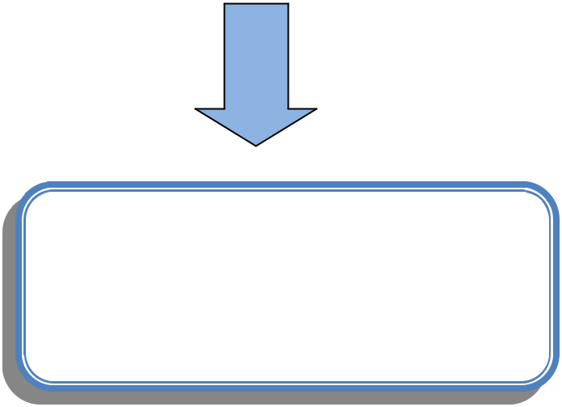

The activity constitutes research involving human subjects. 28 CFR part 46 does apply. Contact your grant manager for further information regarding federal protections of human subjects.

Human subjects are not involved.


28 C.F.R. part 46 does not apply.

