REQUEST FOR PROPOSAL TEMPLATE

This Request for Proposal (RFP) Template is free for you to copy and use on your project and within your organization. We hope that you find this template useful and welcome your comments. Public distribution of this document is only permitted from the Replicon official website at:

www.replicon.com

REQUEST FOR PROPOSAL (RFP)

<PROJECT NAME>

<COMPANY LOGO>

COMPANY NAME

STREET ADDRESS
CITY, STATE ZIP CODE

DATE
Table of Contents

1 | Introduction............................................................................................................................ |  | 3
 | 1.1 | Purpose of the RFP................................................................................................................. | 3
 | 1.2 | Scope of Work ........................................................................................................................ | 3
 | 1.3 | Confidentiality ........................................................................................................................ | 3
2 | Vendor Instructions ................................................................................................................ |  | 4
 | 2.1 | Background............................................................................................................................. | 4
 | 2.2 | General Instructions............................................................................................................... | 4
 | 2.3 | RFP Changes, Binding Bid Process.......................................................................................... | 4
 | 2.4 | Disqualification....................................................................................................................... | 5
 | 2.5 | Structure of the Response...................................................................................................... | 5
 | 2.6 | Schedule of Events ................................................................................................................. | 5
 | 2.7 | Contacts.................................................................................................................................. | 6
 | 2.8 | Evaluation Criteria.................................................................................................................. | 6
 | 2.9 | Awarding of Contract ............................................................................................................. | 7
3 | Vendor Eligibility Criteria ........................................................................................................ |  | 7
4 | Compliance Matrix.................................................................................................................. |  | 8
 | 4.1 | Technical/Functional .............................................................................................................. | 9
 | 4.2 | Security / Hosting ................................................................................................................... | 9
 | 4.3 | Performance......................................................................................................................... | 10
 | 4.4 | Integration............................................................................................................................ | 10
 | 4.5 | Reporting.............................................................................................................................. | 10
 | 4.6 | Others................................................................................................................................... | 11
5 | Pricing Details....................................................................................................................... |  | 11

2 | P a g e
1 Introduction

<<Your Company Overview>>

This Request for Proposal (RFP) is to invite prospective vendors to submit a proposal toprovide <<XYZ>> system to <<Company Name>>. The RFP provides vendors with the relevant operational, performance, application, and architectural requirements that the system must fulfill.

This document describes the Request for Proposal (RFP) from <<Company Name>>. This document is a company confidential document. Vendors requested for proposal are engaged to respect the confidentiality of information contained in this document.

Rules for tendering this RFP are explained in Section2.

1.1 Purpose of the RFP

<<Company Name>>is selecting a solution/service provider for a <<XYZ>>system. Our objective is to select the vendor who most fully meets the requirements identified in this Request for Proposal (RFP). <<Company Name>> may elect to award a contract pursuant to the RFP. Your company is invited to take part in this process and provide a proposal that satisfies <<Company Name>> requirements.

Within the RFP you will find all the information necessary to do a proper assessment of <<Company Name>> requirements. Service providers are invited to respond to this RFP by describing how they can meet the requirements set out in this RFP and by providing other information requested. Responses to this RFP will be used to qualify service providers for the final evaluation and price negotiation phases of the selection process.

1.2 Scope of Work

<Please include a short introduction about the objective of the project, expected deliverables, etc.>.

This could cover the following:

- project goals

- objectives

- deliverables

- scope

- stakeholders / number of employees

- Other basic information about the project

1.3 Confidentiality

This Request for Proposal, including any other material and information provided by <<Company Name>>, contains <<Company Name>>proprietary and confidential information that is provided to you for your exclusive use in evaluating and preparing your response. If at any time your company decides not to respond to the RFP, please destroy any copies of the document and confirm your non-‐participation either in writing or by email.

3 | P a g e
This document should not be duplicated except as necessary to prepare your response. This document should not be disclosed or distributed to any third party. All copies of this document except one file copy should be destroyed following submission of your response. The file copy should be held confidential and not used for any purpose other than bid evaluation, response preparation, and subsequent discussions with <<Company Name>>, if any result. You should safeguard the confidentiality of this document and any copies with the same degree of care with which you safeguard your own confidential information. Vendors may not use the name, logo, or trademarks of <<Company Name>>in connection with any advertising or publicity materials or activities without the prior written consent of the <<Company Name>>. The obligation not to disclose any confidential information shall not be affected by bankruptcy, receivership, assignment, attachment or seizure procedures, whether initiated by or against the vendor, nor by the rejection of any agreement between the <<Company Name>>and the vendor, by a trustee of the vendor in bankruptcy, or by the vendor as a debtor-‐in-‐possession or the equivalent of any of the foregoing under local law.

2 Vendor Instructions

2.1 Background

This RFP has been issued to organizations that will respond satisfactorily to the Request for Proposals (RFP) dated <<DATE>>. The RFP identifies <<Company Name>>’s requirements in sufficient detail in order to identify a preferred vendor.

2.2 General Instructions

Vendors are requested to consider the following instructions when preparing their responses:

- Only respondents who have been directly invited to respond tothis RFP shall be considered.

- Vendor responses must be valid for 6 months from the date of submission.

- Vendors must be commercially bound to their response.
- Vendors must address all matters raised in this RFP.
- Any statements made about the performance and specifications of the proposed solution will be considered to be true and will be incorporated into the final purchase contract.
- Any functionality or features not included in the cost estimate must be clearly identified in the response to the RFP.
- Vendors must address all items specified in this RFP. Failure to adhere to the specified format may disqualify a vendor from further consideration.

Submission of proposals shall constitute evidence that the vendor has made all the above-‐ mentioned examinations, and is free of any uncertainty with respect to conditions that would affect the execution, and completion of this project.

2.3 RFP Changes, Binding Bid Process

<<Company Name>>reserves the right to negotiate any or all RFP terms and conditions, and to cancel, amend or resubmit this RFP in part or entirety at any time. This RFP has been issued exclusively for providing adequate information about <<XYZ>> System requirements for <<Company Name>>in order to receive a proposal of this project from vendors. While one or more vendors may be selected as candidates, and <<Company Name>> may negotiate a vendor contract with one or more respondents, <<Company Name>> reserves the right to reject any or all of the responses

4 | P a g e
received for any reason or no reason, and to decline negotiating and signing a vendor contract with any vendors responding to the RFP regardless of whether any vendor's response is partially or fully accepted or rejected, or contains the highest or lowest mark-‐up or price, or the most timely services delivery commitment, or whether a vendor responds with a no-‐response notice or has an existing contract with <<Company Name>>, and regardless of any other matter. <<Company Name>> further reserves the right to negotiate with any vendor who does not receive this RFP. Accordingly responses should be submitted in the terms most favorable to <<Company Name>>. <<Company Name>> will consider vendor responses as binding offers by vendors.

2.4 Disqualification

Statements known to be, or subsequently found to be, inaccurate or misleading may disqualify the vendor from further participation in the evaluation process.

2.5 Structure of the Response

All responses to this proposal must follow the structure given below:

- Executive Summary

- Company Profile
(Describe your organization’s core businesses,products, services, markets, awards, etc.)
- Similar Experience & Customer References

- Requirements Understanding / Scope of Work
(Please illustrate that you have understood our requirements.)
- Vendor Eligibility Criteria (as per section 3 of RFP)

- Compliance Matrix (as per section 4 of RFP)
- Proposed Solution Description with screenshots of the interface
- Implementation Approach / Deliverables / Training Details
- Post Implementation Support / SLA
- Project Plan / Timelines

- Project Management Approach
(Please illustrate your project management approach in terms of proposed team structure, communication plan, escalation management, quality plan and any other relevant information)

- Pricing Details (as per format in section 5 of the RFP)

2.6 Schedule of Events


 | Event |  |  |  | Date
 | RFP Distribution to Vendors
 | Written Confirmation of Vendors with Bid Intention
 | Questions from Vendors about scope or approachdue
 | Responses to Vendors about scope or approach due
 | Proposal Due Date
 | Target Date for Review of Proposals
 |  |  | 5 | P a g e


Onsite Oral Presentation / Demo of the proposed solution

Final Vendor Selection Discussion(s)-‐-‐Week of

Anticipated decision and selection of Vendor(s)

Anticipated commencement date of work

Anticipated completion of work

2.7 Contacts

Any questions concerning technical specifications or Statement of Work (SOW)or contractual terms & conditions must be directed to:


Name

Address

Phone

FAX
Email

Responses to the RFP are due by <<DATE>>. Please submit your response in <<hard copy / soft copy>>to:


Name

Address

Phone

FAX
Email

2.8 Evaluation Criteria

Any award to be made pursuant to this RFP will be based upon theproposal with appropriate consideration given to operational, technical, cost, and management requirements. Evaluation of offers will be based upon the Vendor’s responsiveness to the RFP and the total price quoted for all items covered by the RFP.

Proposals must address all the items identified in the Request. All proposals will be evaluated based on the following criteria:

- Completeness of proposal
- Experience and past performance with similar customers
- Ability to meet requirements as specified in theCompliance Matrix
- Initial cost, including goods and services, yearly maintenance fee, and any recurring costs
- Financial stability of your company

6 | P a g e
- Demonstrated quality of service and training

- Flexibility of product
- Oral presentation

<<Company Name>> does not represent that these are the sole criteria and reserves the right to adjust selection criteria at any time.

2.9 Awarding of Contract

<<Company Name>> is not bound to accept the lowest proposal and is not obliged to give a reason for rejecting a proposal. Prospective suppliers are advised that nothing in this documentation, or in any communication between <<Company Name>> and any other party, shall be taken as constituting a contract, agreement or representation between <<Company Name>> and/or any other party, except for a formal award of contract made in writing by <<Company Name>>. Neither shall it, or they, be taken as constituting a contract, agreement or representation that a contract shall be offered.

Please note that <<Company Name>> reserves the right to vary the number of vendors invited to interviews and presentations, or dispense completely with this part of the process, at its sole discretion. <<Company Name>> reserves the right at all points in the procurement process either not to select a candidate to go forward to the next stage, or following completion of the procurement process, not to make any award of contract.

<<Company Name>> has prepared this RFP in good faith. To the extent that<<Company Name>> is permitted by law, <<Company Name>> excludes any liability (whether in contract, negligence or otherwise) for any incorrect or misleading information contained in this RFP.

3 Vendor Eligibility Criteria

<<Below are a few sample eligibility criteria, please incorporate/modify as per your specific requirements>>

- Vendor is defined as an independent company registered in 'country name' or a consortium of partnership between a local 'country name' registered company and local or global services partner. Please provide the following details:

o Legal Name:
o Parent Company:
o Corporate Headquarter Address: o Internet Address:
o In what business area has your company engaged?
o How many years has your company been in business under its present name?
o If you are a corporation or limited liability corporation, show state and date of incorporation.
o Is there, or has there been in the last three years, any litigation or governmental or regulatory action pending or threatened against your organization that might affect your ability to provide stated products and services? State the status of any current or pending lawsuits.

- The business enterprise must currently be incorporated, or registered as a company(corporation, limited, partnership) and be able to demonstrate that it has been and

7 | P a g e
is offering goods/services under the business name for a period not less than 5 years. Sole Proprietors/Independent Contractors must be able to demonstrate that they have been engaged in their business activity for not less than 5 years.

- Minimum amount of yearly turnover of the company/vendor during the last three years ie.. for 2010-‐11, 2011-‐12, 2012-‐13 should be at least <<$$>>.

- The vendor should have the experience of providing cloud based solutions/services for at least 5 years.

- Vendor security policies and processes should have been ratified, evaluated and rated by a reputed third party analyst firm such as Gartner/Forrester, please provide details.

- Vendor should have experience of implementing and providing services using cloud based <<XYZ>>Tools in at least 3 organizations in 'country name' and 5 organizations in 'region name'; references should be provided for the same.

- Vendor must have the experience of integrating the proposed <<XYZ>> tool with other third party applications such as QuickBooks, MS Project, PeopleSoft, SAP etc. for unidirectional / bidirectional communication as per requirement to automate the entire process. Please provide details with customer references to substantiate.

- The SaaS provider will need to provide sufficient evidence that its platforms will scale to meet current peak and future application processing and user demands through the use of customer references with similar requirements. SaaS vendors with a good track record will be able to provide and guarantee response times with the required service levels.

- Vendor controls and processes should be SSAE16 compliant. Please attach certificate/report.

- Vendor providing remotely hosted / SaaS based offerings should host the solution in a Tier 4 data center and maintain a separate disaster recovery site, please provide details.

- We have a strong commitment and preference to the consideration and use of certified minority and women-‐owned businesses (M/WBE’s) to the greatest extent possible. Bidder shall provide details, if applicable.

The eligibility will be seen based on the above criteria and <<Company Name>> has the right to reject responses not meeting the qualification criteria.

4 Compliance Matrix

In the subsequent sections, we have detailed the specifications for the various components of the requirement. Vendors must highlight their compliance status against each requirement or specification in their response along with additional comments (if any) by using the following legend:


Solution Features

S = Standard

N = Not Available
C = Available with Customization
T = Available through 3rd-‐party

8 | P a g e

4.1 Technical/Functional
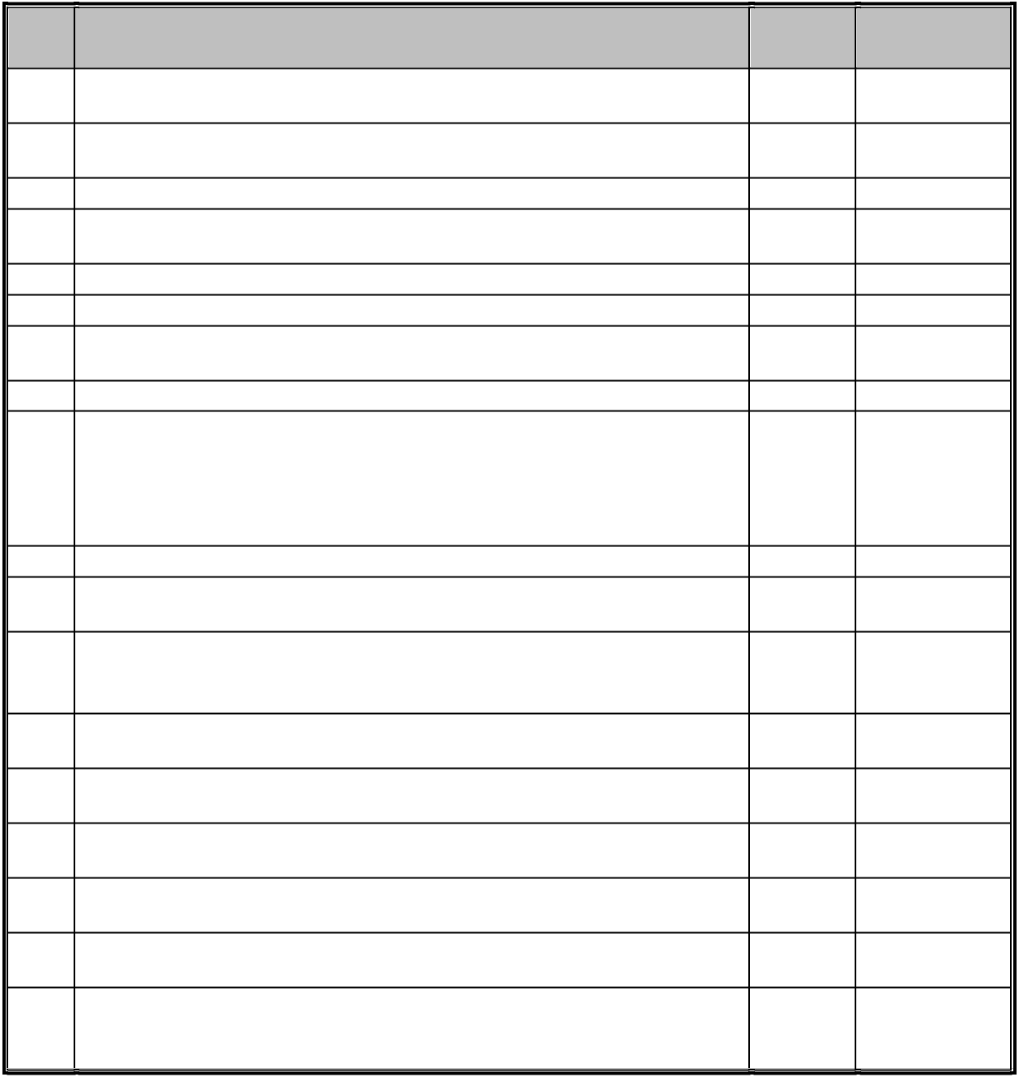

Sr.

No.

1

2

3

4

5

6

7

8

9

10

11

12

13

14

15

16

17

18

Requirements S/N/C/T Additional

Remarks

The system must allow minimum working hours to be defined for all or some users The system must allow different working patterns, to cater for part-‐time and other flexible working arrangements, for some or all users

The system must allow user accounts to be suspended and re-‐instated

The system must allow for different overtime categories to be defined (single time, double time, etc)

The system must allow an employee's contracted hours to be defined Pre-‐population of timesheets based on project allocations

The System must allow user to copy forward historical pattern of work to pre-‐populate future weeks

The System must be able to save data without submitting for approval

The System must have an escalation process in place to flag via email or workflow, that time has not been approved by the approving manager. Approvers must be clearly prompted which approvals are missing when they access the system. Similarly, users should be reminded via email notifications from the system if timesheet is due or overdue.

Option to define approval paths up to minimum five levels deep

The system must allow a different approval path to be defined foreach user Manager should be able to approve or Reject the request directly from the email or the tool. In case the Manager rejects the request, a comment field should be available to mention the reason.

Approvers must be able to select adeputy to approve in their absence from the approved list.

Users must be able to nominate another user to act as their deputy in case of absence etc. The system must allow administrators to restrict who can act as a deputy / substitute. System data should be available for download and analysis

System should allow creation of extensive overtime rules as per company / state policy and should also provide out of the box templates.

The system should ensure compliance with built-‐in/customizable alerts, emails, and approval capabilities; providing what is needed for government audits such as DCAA, SOX, etc.

4.2 Security / Hosting


Sr.

No.

1

2

3

4

Requirements S/N/C/T

Users must not be able to view any staffrecords other than their own.

The system must provide adequate security to prevent unauthorized access The system must provide the facility for passwords to be changed, and for the administrator to configure the frequency with which this should occur as well as setting up password constraints.

Ability to sign in using password authentication that is synchronized with the firm’s Active Directory services

Additional

Remarks

9 | P a g e

5

6

7

8

9

10

Support for deployment of Single Sign-‐on (SSO) with SAML


The system must allow for encryption of information both inbound and outbound. The system must provide an automatic time-‐out facility to prevent users remaining logged in when their sessions are inactive.

The security features provided in the system and by the hosting facility should be compliant with the relevant industry recognized security standards. Please provide details along with supporting documents.

The system must be externally hosted and supported within a jurisdiction with appropriate Data Protection legislation.

The system must have an uptime of at least 99.5%. Please provide supporting evidence with your response.

4.3 Performance
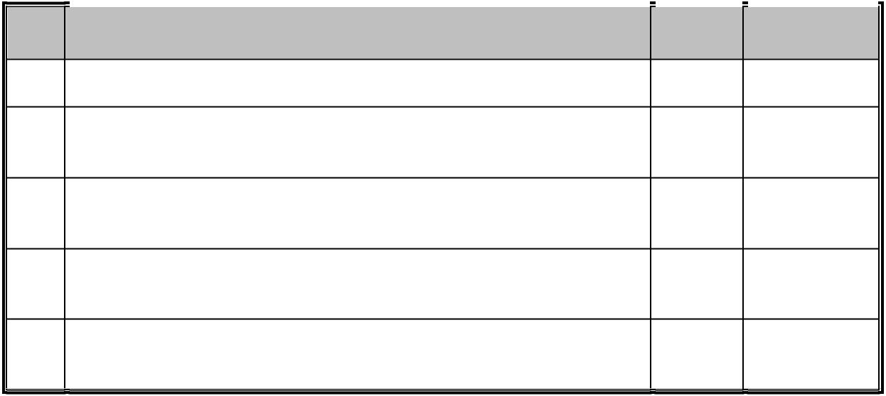

Sr.

No.

1

2

3

4

5

 | Requirements |  | S/N/C/T |  | Additional
 |  |  |  |  | Remarks
Please describe how your solution scales from an infrastructure perspective.

Please describe how your solution's performance scales with the number of concurrent users/sessions online? Does geographic distribution of users affect performance? Please describe.

How do you deal with unexpected peaks in demand/usage? Please include details on whether other customers can affect performance of the environment if shared.

The system must provide sub-‐second response times, as visible to the user, operating over a domestic broadband connection, at least 97% of the time.

The same system must be able to seamlessly scale to cope with initial volume of users (approx. 500) and any additional volume of users without replacing the system.

4.4 | Integration
Sr. |  |  |  | Requirements |  |  | S/N/C/T |  | Additional
No. |  |  |  |  |  |  |  |  | Remarks
1 |  |  | Real-‐time integrations | can be built to almost any other software
 |  |  | solution

- Experience of the vendor and ease of integration with QuickBooks, PeopleSoft, MS Project, etc.
3 API/Web Services availability

4.5 Reporting


Sr.

No.

1

2

3

 | Requirements |  | S/N/C/T |  | Additional
 |  |  |  |  | Remarks
The system must provide a mixture of pre-‐configured and user-‐ defined Management Information reports

The system must allow standard and customized reports against current and archived data.

The system should allow saving of user-‐defined reports for future use.

10 | P a g e

4

5

The system must allow all viewable reports to be printed and produced in electronic form.

Automated reports that can be e-‐mailed to recipients based upon a preset schedule

4.6 | Others
Sr. |  |  |  |  | Requirements |  |  | S/N/C/T
No.
1 |  |  |  | The system should be | capable of being accessed fromany internet
 |  |  |  | device, including mobile devices
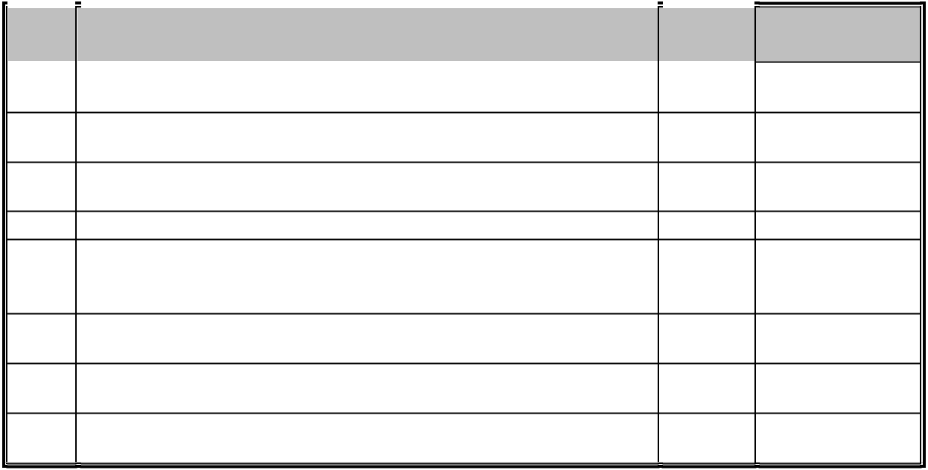
- The system must be able to run on supported versions of Internet Explorer, Chrome, Firefox and Safari
- The system should not require installation of applets or controls to
run on a client
4 The system ideally will have a built-‐in help function

- Upgrades/updates to the system should be frequent (weekly/bi weekly) and should be handled by the vendor without any

downtime.
- The vendor should be able to provide software administrative
training to key staff
- System should support English and local language where legally
required

- Vendor should provide 24x7x365 support services with a real person to assist when needed, please provide details.

Additional

Remarks

5 Pricing Details

All prices quoted by the vendor must be fully itemized, in <<currency name>>, and inclusive of all taxes and all expenses. <<Company Name>> expects to contract with the vendor on a Fixed Price basis for all components of the supply. We expect the vendor to quote a fixed price for:

- Product

- Implementation services
- Customizations
- All software licenses for the vendor’s products

- All software licenses for third party products supplied by the Vendor
- Support fees for one (1) year commencing from date of go-‐live

Please clearly identify all assumptions made when producing these prices.

11 | P a g e

