SFI Research Centre Annual/Progress Report Template

Purpose of the Annual/Progress Report

- The Annual/Progress Report provides SFI with an update on the progress of an SFI Research Centre, allowing for effective oversight and support by the Foundation.

- The Progress Report is a key document provided to expert reviewers ahead of site reviews of SFI Research Centres. Reviewers will receive a single Progress Report covering the period since the previous progress review. Note that they can request access to earlier Annual and Progress Reports if they deem it necessary.

- Annual/Progress Reports enable SFI to inform key stakeholders and interest groups of the outputs, achievements and impact of the SFI Research Centres, including the Department of Business, Enterprise and Innovation, other government departments, sister agencies, the SFI Board, and the general public, who ultimately fund the research. SFI works with these and other groups to develop and improve Ireland’s research ecosystem. For this reason, it is important that we understand the challenges and setbacks that SFI Research Centres face so we can continue to work to increase
Ireland’s research potential.

General instructions

All instructions (red text) in this template, including those on this page, should be deleted/replaced in the final version.

The front cover must meet SFI Research Centre branding guidelines, with the SFI branding lock-up above the title, and the host and partner institutions lock-up below. The full SFI Research Centre name should be used on the front cover, and the reporting period should be clearly indicated.

Section page limits are not target lengths, and it is up to Centres to decide how long is appropriate, up to the limit indicated. Duplication of information across section should be kept to a minimum. Section 2 (Research Centre Overview) may contain some information that is also presented in other sections, but this should be in the form of a high-level summary. Likewise, APPENDIX II - Responses to Recommendations, can contain information duplicated in other sections.

Images do not count towards page limits, with the exception of the Executive Summary.

All text should be in Times New Roman font or similar, with minimum font size of 11, and at least single-line spacing as well as a minimum margin size of 2.5cm. Text in diagrams should be in a clearly legible font. Include page numbers.

The document must be saved in a format that preserves links from the table of contents to individual sections in the report.

Please note that the final section, APPENDIX III – Research Activities, should be submitted as a separate file, and should have its own table of contents that links to each project.
Deadline

In a year when an SFI Research Centre is not undergoing a site review, an Annual Report covering the previous calendar year is due on the last working day in March.

In a year when an SFI Research Centre is undergoing a site review, a Progress Report covering the period since the previous progress review is due 3 months prior to the date of the upcoming site review. Your Scientific Programme Manager will inform you of the submission deadline.

Differences between Annual Report and Progress Report

Annual reports and Progress Reports differ in the following ways:

- An Annual Report covers the period since the previous Report (Annual or Progress). A Progress Report covers the period since the previous site review, or since the start of the SFI Research
Centre’s activities if no site review has taken place yet.

- APPENDIX II – Responses to Recommendations, is not completed in an Annual Report (or for a Progress Report where no previous review has taken place).

- In APPENDIX III – Research Activities, Section A and Section B are completed in a Progress Report. In an Annual Report only Section A is completed.

Contents

1. Executive Summary 1

2. SFI Research Centre Overview 2

3. SFI Research Centre Team 3

4. Research 4

5. Education and Public Engagement 6

6. KPI performance 8

7. Funding Diversification 9

8. Centre impact 10

9. Communications 11

APPENDIX I – Clinical Trials and Clinical Investigations 12

APPENDIX II – Responses to Recommendations 13

APPENDIX III – Research Activities 14
1. Executive Summary (max. 2 pages)

The executive summary should be readable by a broad audience.

1.1 Strategy

Comment on how the Centre is performing against its strategy, and whether any changes have been made to the Centres strategy during the reporting period. This should include new opportunities identified by the Centre.

1.2 Accomplishments

Summarise significant accomplishments during the reporting period. These can be from any area of the Centre’s activities, including research advances, industry engagement, EPE achievements, notable hires, etc.

1.3 Challenges

Discuss key challenges or setbacks the Centre has experienced during the reporting period, and how the Centre has responded to these challenges. Also note if any future risks have been identified, and summarise the actions being taken to manage or address these risks.

1
2. SFI Research Centre Overview (max. 8 pages, excluding images)

The title of this section can be replaced with ‘[Centre acronym] Overview’.

2.1 Strategy

Discuss the Centre’s long-term direction.

Include alignment with current national priorities and industry sectors.

Present a SWOT (Strengths, Weaknesses, Opportunities, and Threats) analysis of the Centre.

2.2 Research Centre Structure

Use a schematic to illustrate how the Research Centre is structured across research strands/themes, platform research, targeted projects, spokes etc.

2.3 Team

Use an organigramme to present a high-level view of the Centre’s team. This should clearly map to the research centre structure included in section 2.2 and detail the co-PIs that lead research strands/themes.

2.4 Budget

Provide high level figures on the Centre’s budget from SFI, industry and non-exchequer non-commercial sources. Specify the budgets allocated to both the research strands/themes illustrated in section 2.2 and the Centre’s partner institutions.

Use pie-charts or other illustrations to aid in this.

2.5 International benchmarking

Benchmark the Centre against other, similar research entities around the world.

Ideally, benchmarking should aim to cover many of the same outputs and KPIs reported by SFI Research Centres, but benchmarking can include other factors that are deemed to be relevant comparators, such as personnel and budget.

Refer to any plans to address areas where the Centre does not perform highly internationally.

2.6 Collaboration with other research groups and Centres

Discuss active collaborations with other research groups and Centres, such as those that arose through EU-funded collaborative awards. Detail any efforts to collaborate with other SFI Research Centres and highlight prominent collaborations established during the reporting period.

2
3. SFI Research Centre Team (max. 10 pages, excluding images)

The title of this section can be replaced with ‘[Centre acronym] Team’.

3.1 Team overview

Provide brief bio-sketches of the Centre’s management team, including Director(s), co-PIs, FIs, and Operations team members. Each bio-sketch should provide a synopsis of what the team member brings to the Centre in terms of expertise and experience, and also include their current role and responsibilities.

Detail any changes made to the Research Centre team during the reporting period and describe the impact that such changes have had on the Centre.

3.2 Governance and Advisory committees

Provide a brief outline of the governance and advisory committee structures of the Centre.

Highlight changes in composition that occurred during the reporting period.

3.3 Talent development and recruitment

Describe the Centre’s approach to talent development among its staff and researchers, and any significant activities that have taken place during the reporting period.

Comment on recruitment, with reference to any delays that have occurred as well as future plans.

3.4 Gender equality

Describe and explain the breakdown of gender representation within the SFI Research Centre, with breakdowns for different levels within the Centre (Director and co-lead Applicants, Funded Investigators, postdoctoral researchers and students). Describe any action undertaken to redress gender under-representation within the Centre, particularly at senior levels. Describe other supports for gender equality initiatives.

3.5 Spread of efforts across institutions

Discuss the extent to which different institutional partners are engaged in Centre activities, and efforts made by Centre leadership to involve a wide research community across Ireland.

3
4. Research (max. 10 pages, excluding images)

Please note that detailed updates on research projects should not be entered in this section, but instead should be entered in APPENDIX II - Research Activities (see below).

4.1 Research team organigramme

Provide a more detailed organisational chart than that shown in section 2.3 that visualises the co-PIs leading research themes, and the co-PIs and FIs that work under them. The overall budget assigned to the theme should be included in the chart, and the host/partner institution of each co-PI/FI should be visible.

A simplified example of the detailed organigramme is shown below. Centres are free to use a style that suits the Centre best, once the requested information – research theme, PIs/FIs with Research Bodies, and hierarchical structure – is clearly shown. The organigramme should be broken into separate themes/domains and/or displayed in landscape orientation if it is too large to be conveniently displayed on a standard A4 sheet.
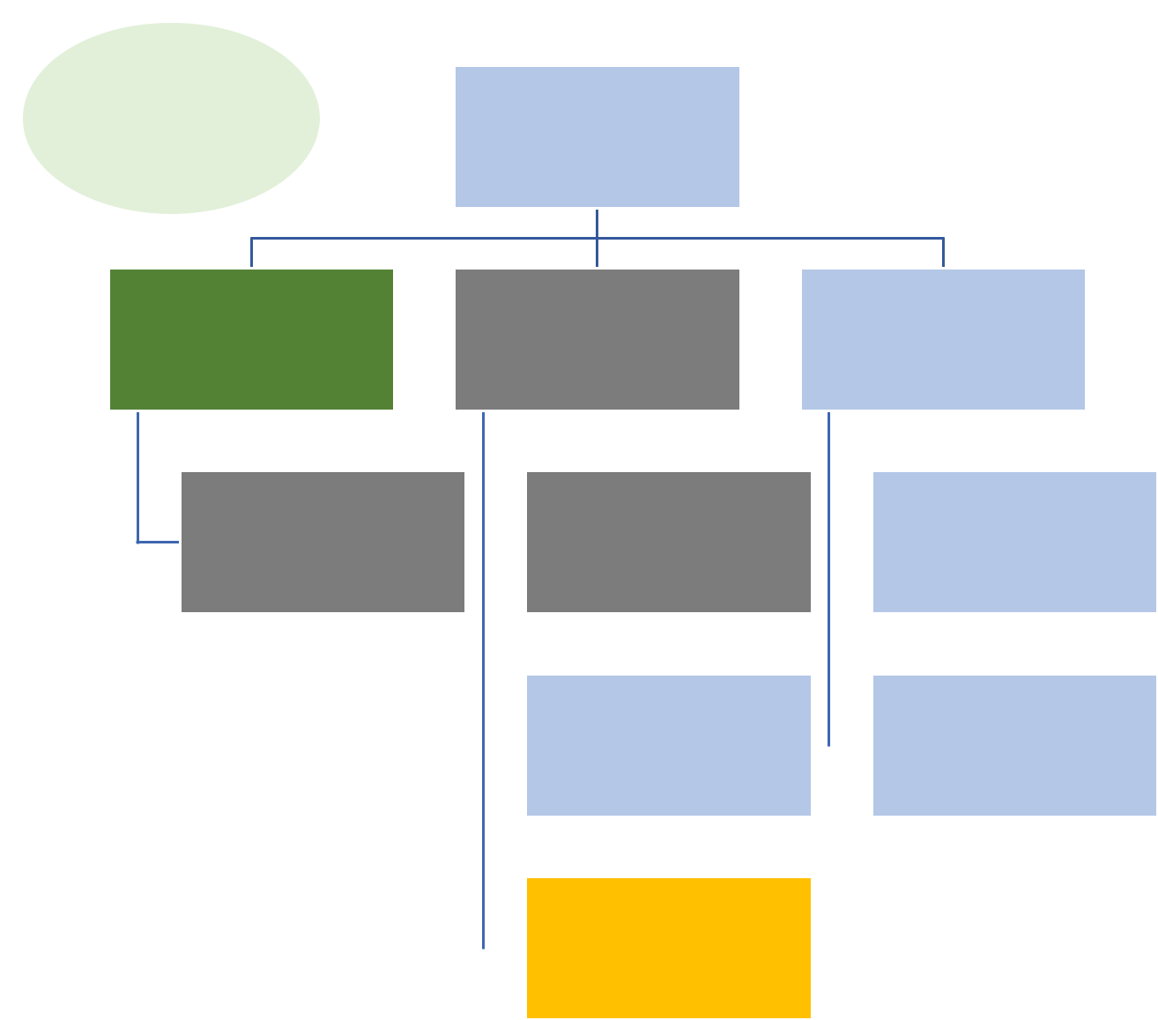

Theme Budget:

€…….

Theme 1
Leader

PI 2 | PI 3 | PI 3

FI 1 |  | FI 2 |  | FI 5

 | Research Body 1 |  |  |  | FI 3 |  | FI 6
 | Research Body 2
 | Research Body 3
 |  |  |  |  | FI 4
 | Research Body 4 |  |  |  | FI 4

4

4.2 Changes to the Centre’s research structure

Discuss any significant changes to the research structure during the reporting period.

4.3 Notable breakthroughs and publications

Describe the most important breakthroughs that the Centre has made during the reporting period, clearly outlining what the breakthrough is, why it is important, how it has been translated and who has or will benefit from it. These descriptions should be understandable by non-experts.

Highlight the Centre’s ten most significant publications during the reporting period, include surrounding narrative that clearly explains, in non-scientific language, why these papers are important.

4.4 Good research practices

Describe how the Centre promotes good research practices. Reference specific actions, including data management and training.

4.5 Future plans

Describe the Centre’s plans for the next reporting period, highlighting any planned changes to the research programme.

5
5. Education and Public Engagement (max. 10 pages, excluding images)

5.1 EPE strategy and budget

Give an overview of the Centre’s EPE plan, and progress to date against the EPE operational plan.

Highlight and explain any deviations from this plan.

Present the EPE budget during the reporting period. This should not be limited to the SFI budget.

5.2 EPE activities

Describe the Centre’s key EPE activities, using the outline below. The number of activities chosen is up to Centres, but major activities listed in the EPE plans during the reporting period should be a focus.

Activity Title

Vision and objectives:

Include the target groups, why these groups were chosen, and if they include underrepresented groups.

Inputs:

How many Centre staff members participated? What other inputs were required (consumables, equipment etc)? Specify the expenditure for this activity. Did industry partners contribute staff time/resources? Highlight any industry cash/other in-kind contributions received.

Outputs:

Outline the type of events/activities delivered. How many participants were directly engaged? Include a brief description of any challenges encountered, the causes and how they were overcome. Highlight any recommendations to help prevent similar challenges in future projects/activities.

Outcomes and evaluation:

Outline the outcomes expected or achieved. Explain how you evaluated the activity – include methodology, findings and dissemination. Indicate whether objectives and expected outcomes were met/exceeded/not met, and why. Indicate where outcomes of an activity influenced other activities, in particular the research programme.

5.3 Additional activities completed during the reporting period

These are any EPE activities other than the key activities outlined above.

Activity | Audience | Numbers engaged | Frequency of
 |  |  | engagement

6

5.4 Future plans for EPE programme

Detail areas identified for future development, including specific gaps in population engagement or resource development.

7
6. KPI performance (max. 10 pages, excluding images)

This section should begin with a validated table of the Centre’s KPI results against targets for the reporting period and cumulatively to date.

Discuss the Centre’s performance against each of the KPI targets for the reporting period and cumulatively to date. Please note, this is with the exception of KPIs for industry cost share and non-exchequer/non-commercial funding which will be discussed in section 7 below.

This discussion should include the challenges and setbacks that have been encountered, and the Centre’s strategy for achieving the KPI targets.

8
7. Funding Diversification (max. 10 pages, excluding images)

This section should begin with a validated table of the Centre’s industry cost share results against targets and non-exchequer non-commercial KPI results (Phase 1 Research Centre)/non-exchequer non-commercial cost share results (Phase 2 Research Centre) against targets for the reporting period and cumulatively to date.

7.1 Commercial strategy and industry cost share

Describe the Centre’s commercial strategy and discuss the Centre’s performance against its industry cost share targets for the reporting period and cumulatively to date. Highlight any significant successes, setbacks and challenges during the reporting period, and comment on any changes to the Centre’s commercial strategy.

7.2 Non-exchequer non-commercial funding

Describe the Centre’s strategy to leverage non-exchequer non-commercial funding and discuss the Centre’s performance against its KPI target (Phase 1)/cost share target (Phase 2). Highlight any significant successes, setbacks and challenges during the reporting period and comment on any changes to the Centre’s non-exchequer non-commercial strategy.

7.3 Additional exchequer funding

Discuss other exchequer funding that the Centre has secured and detail the contribution that this funding has made to Centre activities and the delivery of the Centre’s strategy.

9
8. Centre impact (max. 5 pages, excluding images)

Before completing this section, please consult with SFI’s information and guidance on reporting on the impact arising from its funding, which can be found on the SFI website under Research Impact.

Discuss the impact arising from the Centre’s activities during the reporting period. Include individual case studies where the Centre has used its knowledge and research ideas to create impact at an economic, societal, international engagement, policy and public service, health and wellbeing, environment professional services, or human capacity level, either in Ireland or internationally.

Reference should be made to the impact statement submitted as part of the original proposal.

10
9. Communications (max. 10 pages, excluding images)

9.1 SFI Research Centre communications plan

Discuss how the Centre has used strategic communications to support its goals and to promote itself as a world leading SFI Research Centre during the previous year.

9.2 Communications activities

Provide an overview of national and international communications/marketing actions undertaken by the

Centre, broken into different sections including:

- engagement with key stakeholders to promote the work of the Centre (media, industry, government, etc.),

- marketing/branding/advertising materials produced to promote the Centre,

- online activities, including social media platforms,

- media coverage over the reporting period.

Discuss communications challenges or setbacks that were encountered during the reporting period.

9.3 Communications case studies

Please provide 3-5 case studies highlighting the Centre’s top achievements. These can be highlights from research outputs, EPE, or other Centre activities.

These case studies should present short summaries of:

- challenge/background,

- action and engagement,

- impact,

- next steps (if relevant).

9.4 SFI Research Centre branding

Outline the actions taken to implement SFI Research Centre branding, as detailed in the agreed IUA-SFI guidelines.

Please indicate any outstanding actions relating to the updating of branding and give an estimated completion date for these.

9.5 Evaluation

Explain how you have evaluated communications activities and share any key statistics.

9.6 Future communications plan

Please provide an overview of key plans for the next year.

11
APPENDIX I – Clinical Trials and Clinical Investigations (no page limit)


Trial Name | Lead | Objectives (incl. | Study type | Study Size | Start Date – | Current | Trial | HPRA | Trial | Insurance
 | Investigator | study endpoints | (e.g. RCT) | (expected | End Date | Stage | Sponsor | Approval | Location(s) | Details
 |  |  |  | and current |  | (recruitment |  | Required?
 |  |  |  | recruitment) |  | / treatment/
 |  |  |  |  |  | follow-up)

12

APPENDIX II – Responses to Recommendations (max. 20 pages, excluding images)

This Appendix should only be included in a Progress Report, where a previous review has taken place. This Appendix should not be included in an Annual Report, or in a progress Report of a Centre being reviewed for the first time.

This section should be devoted to setting out how the Centre has responded to the recommendations provided by a previous review panel. Recommendations should be dealt with separately, in clearly marked sections.

13
APPENDIX III – Research Activities (no page limit)

Please note that this appendix should be submitted as a separate file and should have its own table of contents that links to each project.

For each Centre research project e.g. platform project, targeted project (including those funded as part of the SFI Spokes programme), Centre-to-Centre partnership, include a completed ‘Section A – Project overview’.

In the case of a Progress Update (prior to a site review), ‘Section B – Detail’ should be included. For an Annual Report (i.e., in a year with no site review) only ‘Section A’ should be completed for each project. Section B should not be completed.

Only projects that were still active during the reporting period should be reported on. Length and level of detail may vary significantly between sections. Centres should consult with their SFI Scientific Programme Manager for advice on how to complete this appendix, if required.

Projects should be separated with a page break.

Section A – Overview

Project title | Name of the platform project/targeted project/spoke/US-Ireland Centre-to-
Project title | Centre/infrastructure, etc.
Research
theme/strand
PIs | Provide the name and affiliation of each researcher.
FIs
Postdoctoral
researchers
PhDs
Industry
partners
Budget | Overall budget figure for this project, and the contribution of industry cash/in-kind
Budget | to this figure.
 | 14

Technology
readiness level
Project start
date – end date
Key | Key publications resulting from this project during the reporting period.
publications
Other key | Licences, patents, or other notable outputs during the reporting period. Also briefly
outputs and
outputs and | reference impacts resulting from work in this project.
impacts | reference impacts resulting from work in this project.
Project status | Indicate if the project status is ‘Green’, ‘Orange’ or ‘Red’, based on internal
Project status | assessments of progress against the workplan. Provide a very short reason for
 | Orange or Red status.

Section B – Progress Report research project detail

This section should only be included in a Progress Report, and not in an Annual Report.

Goals and strategy

State the overarching objectives and approach of the project.

Note, for awards such as Centre-to-Centre partnerships and additional spokes this section should include more information on the background of the award, and how it fits within the overall strategy of the Centre.

Summary of progress to date

Short summary of the overall progress made on this project. Comment on whether this work is ahead, on track, or behind schedule at this point. Is the budget expenditure on track, if not why?

Progress in the reporting period

Scientific overview of activities within this project. You may include images. Please include discussion of the contribution of any industry partners during the reporting period.

For Centre-to-Centre partnerships, please make clear which work was carried out by which Centre.

This is the main section for the discussion of research work undertaken, and it should be significantly larger than the other sections for this project.

15

Challenges and risks

Comment on any significant issues that have arisen during the reporting period, whether these have impacted on budget/deadlines. How has the Centre worked to reduce the impact of any setbacks?

Future direction

Short description of the planned direction of future work on this project.

16

