

POSTSECONDARY SUCCESS INITIATIVE 2018 – 2019 |  |  |  | Progress Report Template
Partner:X
Allocation: $X |  | Reporting Period: | Quarter 1 May 1, 2018 – September 30, 2018

OBJECTIVES

Significantly more GEAR UP students will be:

- enrolled in postsecondary educa on by the fall semester following their gradua on from high school;

- on track for graduating from college by completing their freshman year in good academic standing;

- placed into college level English and math without the need for remedial courses.


Instructions for completing narrative:

For each Contracted Activity on the left, begin by indicating the status in the Results column (see below definitions) followed by explanatory detail of the status.

Statuses:

Upcoming: No actual progress to date, though activity may be scheduled and/or preparations underway. (Indicate when the activity has been scheduled and what preparation/planning has occurred to date.)

In Progress: Actions have been taken and/or are underway. (Describe progress in detail and identify anticipated completion date.)

Completed: All actions to accomplish contracted activity are complete. (Provide a detailed account of how the activity was completed and your reflections. Did it meet your expectations? Does the activity contribute to systemic change? If so, how?)

___________________________ Community College PSI Progress Report P a g e 1
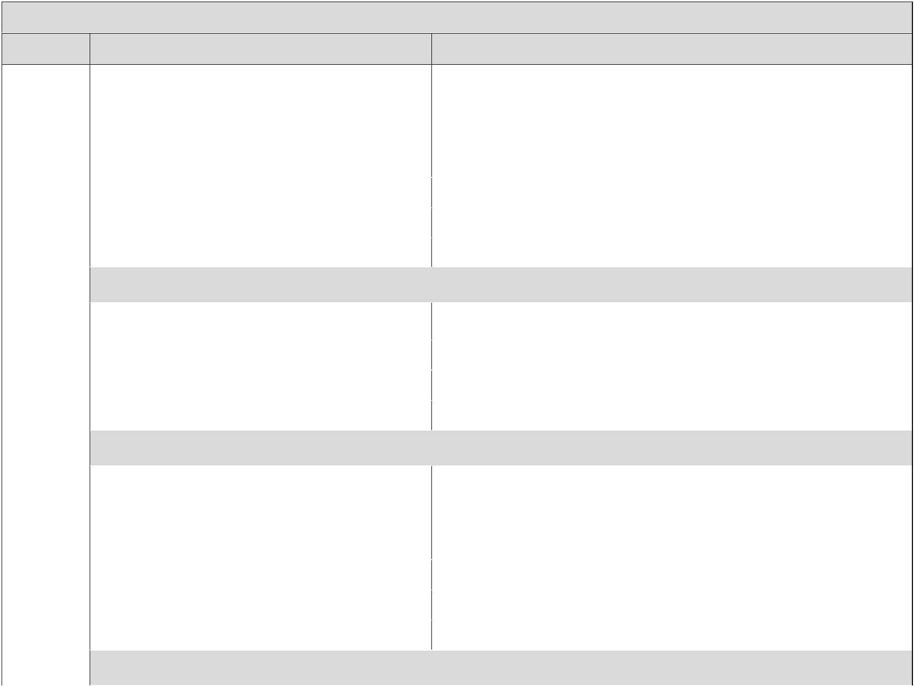
Section 1: Academic Support

Task Contracted Activities Results

Academic 1.1

Support

Actions

Quarter 1: This activity is (choose one) Upcoming In-Progress Completed

Lorem ipsum dolor sit amet, consectetur adipiscing elit. Pellentesque eget placerat leo. Pellentesque eu felis quis odio luctus auctor nec rutrum ipsum. Sed cursus diam pharetra semper maximus. Vivamus consequat posuere purus. Ut sollicitudin venenatis porttitor. Mauris blandit ante arcu, eget venenatis quam maximus ac.

 |  | Quarter 2: This activity is (choose one) | Upcoming | In-Progress | Completed
 |  | Quarter 3: This activity is (choose one) | Upcoming | In-Progress | Completed
 |  | Quarter 4: This activity is (choose one) | Upcoming | In-Progress | Completed
 | NAU COMMENTS:
 |  | Quarter 1: This activity is (choose one) | Upcoming | In-Progress | Completed
1.2
 |  | Quarter 2: This activity is (choose one) | Upcoming | In-Progress | Completed
 |  | Quarter 3: This activity is (choose one) | Upcoming | In-Progress | Completed
 |  | Quarter 4: This activity is (choose one) | Upcoming | In-Progress | Completed
 | NAU COMMENTS:
 |  | Quarter 1: This activity is (choose one) | Upcoming | In-Progress | Completed
1.3 |  | Lorem ipsum dolor sit amet, consectetur adipiscing elit. Donec eget felis
 |  | tortor. Maecenas at ornare erat, vel molestie mauris. Nulla rutrum justo
 |  | nisi, nec viverra odio vestibulum eget. Aenean facilisis dictum purus, ut
 |  | dictum libero ornare ac.
 |  | Quarter 2: This activity is (choose one) | Upcoming | In-Progress | Completed
 |  | Quarter 3: This activity is (choose one) | Upcoming | In-Progress | Completed
 |  | Quarter 4: This activity is (choose one) | Upcoming | In-Progress | Completed
 | NAU COMMENTS:
___________________________ Community College PSI Progress Report |  |  |  |  | P a g e 2

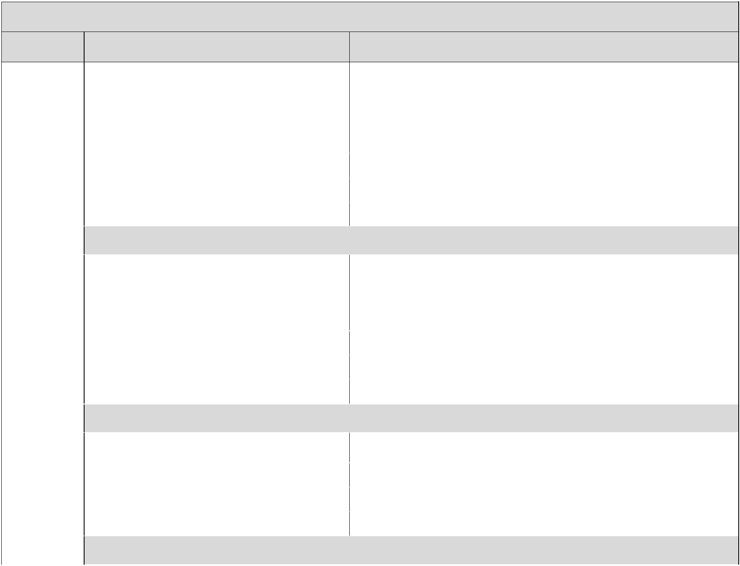
Section 2: Integration and Connections

Task Contracted Activities Results

Integration 2.1

and

Connections

Actions

Quarter 1: This activity is (choose one) Upcoming In-Progress Completed

Lorem ipsum dolor sit amet, consectetur adipiscing elit. Pellentesque eget placerat leo. Pellentesque eu felis quis odio luctus auctor nec rutrum ipsum. Sed cursus diam pharetra semper maximus. Vivamus consequat posuere purus. Ut sollicitudin venenatis porttitor. Mauris blandit ante arcu, eget venenatis quam maximus ac.

 |  | Quarter 2: This activity is (choose one) | Upcoming | In-Progress | Completed
 |  | Quarter 3: This activity is (choose one) | Upcoming | In-Progress | Completed
 |  | Quarter 4: This activity is (choose one) | Upcoming | In-Progress | Completed
 | NAU COMMENTS:
2.2 |  | Quarter 1: This activity is (choose one) | Upcoming | In-Progress | Completed
 |  | Lorem ipsum dolor sit amet, consectetur adipiscing elit. Donec eget felis
 |  | tortor. Maecenas at ornare erat, vel molestie mauris. Nulla rutrum justo
 |  | nisi, nec viverra odio vestibulum eget. Aenean facilisis dictum purus, ut
 |  | dictum libero ornare ac.
 |  | Quarter 2: This activity is (choose one) | Upcoming | In-Progress | Completed
 |  | Quarter 3: This activity is (choose one) | Upcoming | In-Progress | Completed
 |  | Quarter 4: This activity is (choose one) | Upcoming | In-Progress | Completed
 | NAU COMMENTS:
2.3 |  | Quarter 1: This activity is (choose one) | Upcoming | In-Progress | Completed
 |  | Quarter 2: This activity is (choose one) | Upcoming | In-Progress | Completed
 |  | Quarter 3: This activity is (choose one) | Upcoming | In-Progress | Completed
 |  | Quarter 4: This activity is (choose one) | Upcoming | In-Progress | Completed
 | NAU COMMENTS:
___________________________ Community College PSI Progress Report |  |  |  |  | P a g e 3

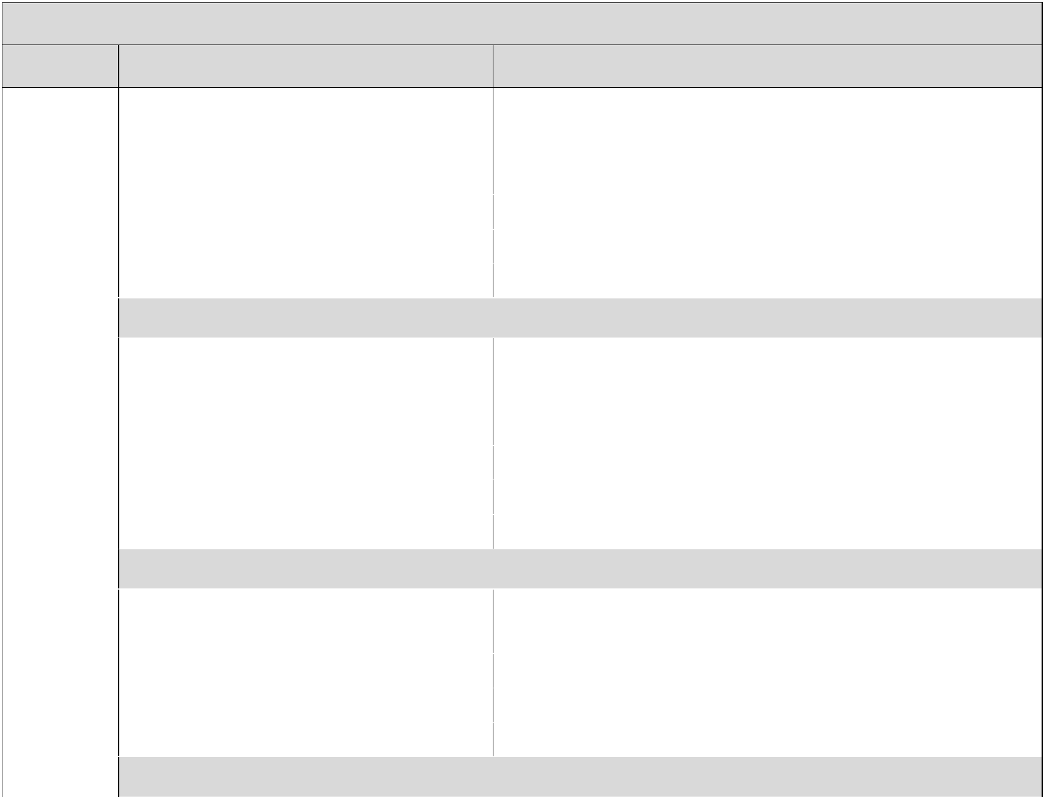
Section 3: Transition Activities

Task Contracted Activities Results

Transition 3.1

Activities

Actions

Quarter 1: This activity is (choose one) Upcoming In-Progress Completed

Lorem ipsum dolor sit amet, consectetur adipiscing elit. Donec eget felis tortor. Maecenas at ornare erat, vel molestie mauris. Nulla rutrum justo nisi, nec viverra odio vestibulum eget. Aenean facilisis dictum purus, ut dictum libero ornare ac.

 |  | Quarter 2: This activity is (choose one) | Upcoming | In-Progress | Completed
 |  | Quarter 3: This activity is (choose one) | Upcoming | In-Progress | Completed
 |  | Quarter 4: This activity is (choose one) | Upcoming | In-Progress | Completed
 | NAU COMMENTS:
3.2 |  | Quarter 1: This activity is (choose one) | Upcoming | In-Progress | Completed
 |  | Lorem ipsum dolor sit amet, consectetur adipiscing elit. Donec eget felis
 |  | tortor. Maecenas at ornare erat, vel molestie mauris. Nulla rutrum justo
 |  | nisi, nec viverra odio vestibulum eget. Aenean facilisis dictum purus, ut
 |  | dictum libero ornare ac.
 |  | Quarter 2: This activity is (choose one) | Upcoming | In-Progress | Completed
 |  | Quarter 3: This activity is (choose one) | Upcoming | In-Progress | Completed
 |  | Quarter 4: This activity is (choose one) | Upcoming | In-Progress | Completed
 | NAU COMMENTS:
3.3 |  | Quarter 1: This activity is (choose one) | Upcoming | In-Progress | Completed
 |  | Lorem ipsum dolor sit amet, consectetur adipiscing elit. Donec eget felis
 |  | tortor. Maecenas at ornare erat, vel molestie mauris.
 |  | Quarter 2: This activity is (choose one) | Upcoming | In-Progress | Completed
 |  | Quarter 3: This activity is (choose one) | Upcoming | In-Progress | Completed
 |  | Quarter 4: This activity is (choose one) | Upcoming | In-Progress | Completed
 | NAU COMMENTS:
___________________________ Community College PSI Progress Report |  |  |  |  | P a g e 4

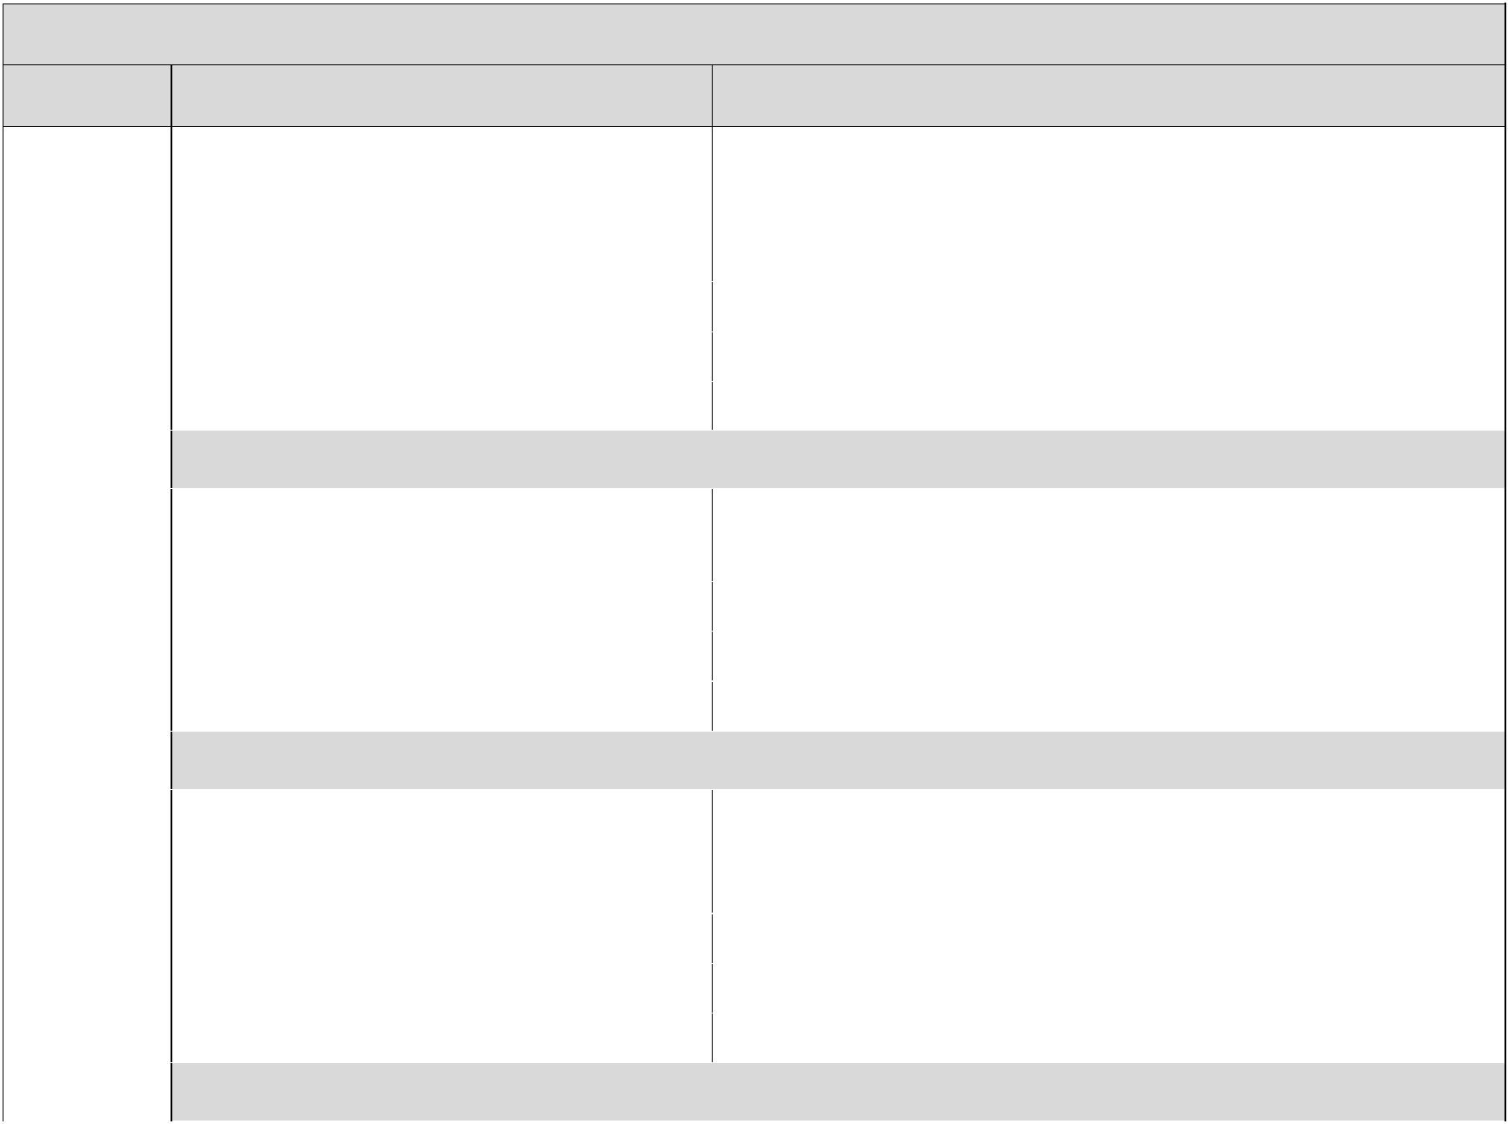
Section 4: Financial Support

Task Contracted Activities Results

Financial 4.1

Support

Actions

Quarter 1: This activity is (choose one) Upcoming In-Progress Completed

Lorem ipsum dolor sit amet, consectetur adipiscing elit. Donec eget felis tortor. Maecenas at ornare erat, vel molestie mauris. Nulla rutrum justo nisi, nec viverra odio vestibulum eget. Aenean facilisis dictum purus, ut dictum libero ornare ac.

 |  | Quarter 2: This activity is (choose one) | Upcoming | In-Progress | Completed
 |  | Quarter 3: This activity is (choose one) | Upcoming | In-Progress | Completed
 |  | Quarter 4: This activity is (choose one) | Upcoming | In-Progress | Completed
 | NAU COMMENTS:
4.2 |  | Quarter 1: This activity is (choose one) | Upcoming | In-Progress | Completed
 |  | Lorem ipsum dolor sit amet, consectetur adipiscing elit. Donec eget felis
 |  | tortor. Maecenas at ornare erat, vel molestie mauris.
 |  | Quarter 2: This activity is (choose one) | Upcoming | In-Progress | Completed
 |  | Quarter 3: This activity is (choose one) | Upcoming | In-Progress | Completed
 |  | Quarter 4: This activity is (choose one) | Upcoming | In-Progress | Completed
 | NAU COMMENTS:
4.3 |  | Quarter 1: This activity is (choose one) | Upcoming | In-Progress | Completed
 |  | Lorem ipsum dolor sit amet, consectetur adipiscing elit. Donec eget felis
 |  | tortor. Maecenas at ornare erat, vel molestie mauris.
 |  | Quarter 2: This activity is (choose one) | Upcoming | In-Progress | Completed
 |  | Quarter 3: This activity is (choose one) | Upcoming | In-Progress | Completed
 |  | Quarter 4: This activity is (choose one) | Upcoming | In-Progress | Completed
 | NAU COMMENTS:
___________________________ Community College PSI Progress Report |  |  |  |  | P a g e 5

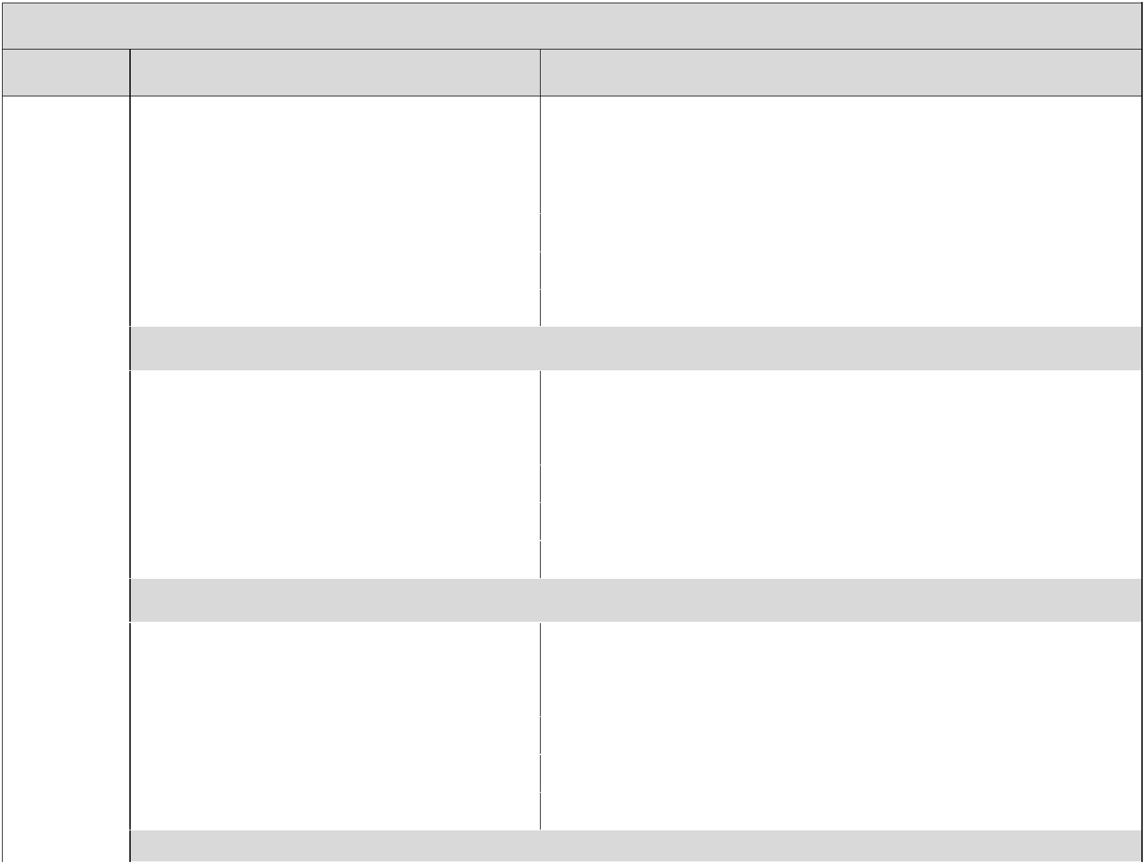
Section 5: Academic Advising

Task Contracted Activities Results

Academic 5.1

Advising

Actions

Quarter 1: This activity is (choose one) Upcoming In-Progress Completed

Lorem ipsum dolor sit amet, consectetur adipiscing elit. Donec eget felis tortor. Maecenas at ornare erat, vel molestie mauris. Nulla rutrum justo nisi, nec viverra odio vestibulum eget. Aenean facilisis dictum purus, ut dictum libero ornare ac.

 |  | Quarter 2: This activity is (choose one) | Upcoming | In-Progress | Completed
 |  | Quarter 3: This activity is (choose one) | Upcoming | In-Progress | Completed
 |  | Quarter 4: This activity is (choose one) | Upcoming | In-Progress | Completed
 | NAU COMMENTS:
5.2 |  | Quarter 1: This activity is (choose one) | Upcoming | In-Progress | Completed
 |  | Lorem ipsum dolor sit amet, consectetur adipiscing elit. Donec eget felis
 |  | tortor. Maecenas at ornare erat, vel molestie mauris. Aenean facilisis
 |  | dictum purus, ut dictum libero ornare ac.
 |  | Quarter 2: This activity is (choose one) | Upcoming | In-Progress | Completed
 |  | Quarter 3: This activity is (choose one) | Upcoming | In-Progress | Completed
 |  | Quarter 4: This activity is (choose one) | Upcoming | In-Progress | Completed
 | NAU COMMENTS:
5.3 |  | Quarter 1: This activity is (choose one) | Upcoming | In-Progress | Completed
 |  | Ut nunc odio, viverra id augue quis, faucibus imperdiet sapien. Curabitur
 |  | ultrices justo mi, sed faucibus odio venenatis vel. Aliquam at enim
 |  | pharetra, pretium tortor ut, mattis velit. Fusce in tristique purus.
 |  | Quarter 2: This activity is (choose one) | Upcoming | In-Progress | Completed
 |  | Quarter 3: This activity is (choose one) | Upcoming | In-Progress | Completed
 |  | Quarter 4: This activity is (choose one) | Upcoming | In-Progress | Completed
 | NAU COMMENTS:
___________________________ Community College PSI Progress Report |  |  |  |  | P a g e 6

