CICO Progress Report Date: _________________

Overall School CICO Report

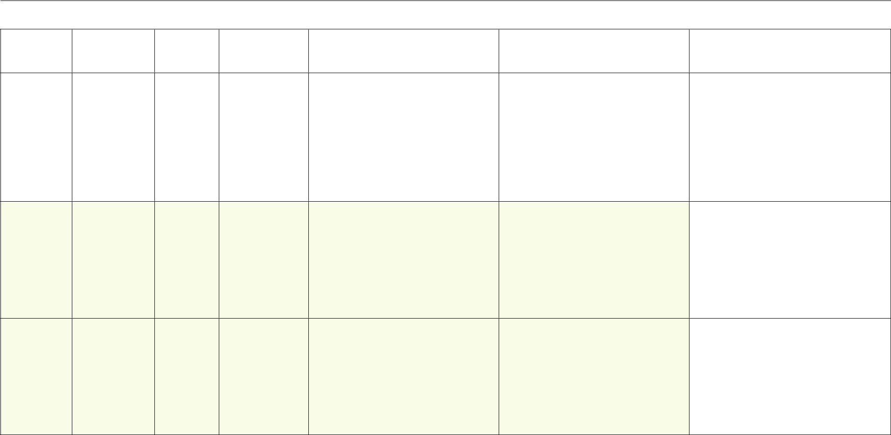

Student |  | Days with Data | Goal |  | Average Daily |  | Progress/Success |  | Barriers/Challenges |  | Consider:
Student |  | Days with Data | Goal |  | Points |  | Progress/Success |  | Barriers/Challenges

☒ Plan change/Modifications

☐ Fading/ Self- Management

☐ More intensive supports

☐

☒ Plan change/Modifications

☐ Fading/ Self- Management

☐ More intensive supports

☐

☐ Plan change/Modifications

☐ Fading/ Self- Management

☐ More intensive supports

☐

