
Trackable Workout Log
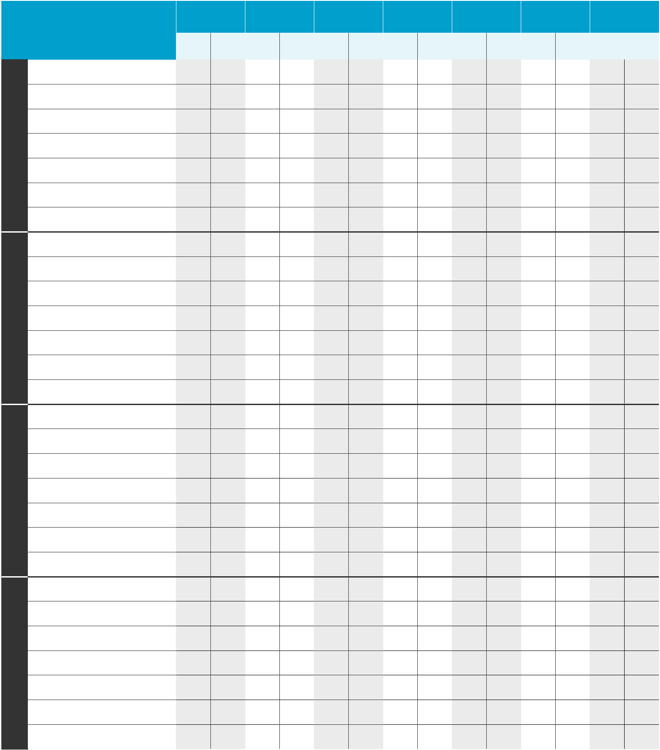

Week 1

Week 2

Week 3

Week 4

Exercise | Sun. | Mon. | Tues. | Weds. | Thurs. | Fri. | Sat.
Exercise | Reps Sets | Reps Sets | Reps Sets | Reps Sets | Reps Sets | Reps Sets | Reps | Sets

Squats

Supermans

Push-ups

Overhead shoulder press

Bicep curls

Tricep chair dips

Plank

Squats

Supermans

Push-ups

Overhead shoulder press

Bicep curls

Tricep chair dips

Plank

Squats

Supermans

Push-ups

Overhead shoulder press

Bicep curls

Tricep chair dips

Plank

Squats

Supermans

Push-ups

Overhead shoulder press

Bicep curls

Tricep chair dips

Plank

©2017 HAP – a nonprofit company 0M 12/17 17-615 1242

