 | Weekly Budget
 |  | Week Of: ___________________
Payee | Amount | Week Of: ___________________
 |  | Amount in Savings: ________________________
 |  | Amount in Bills Acct.: ________________________
 |  | Amount in Spend Acct.: ________________________
 |  | Weekly Spending $: ____________________________
 |  | Weekly Grocery $: ______________________________
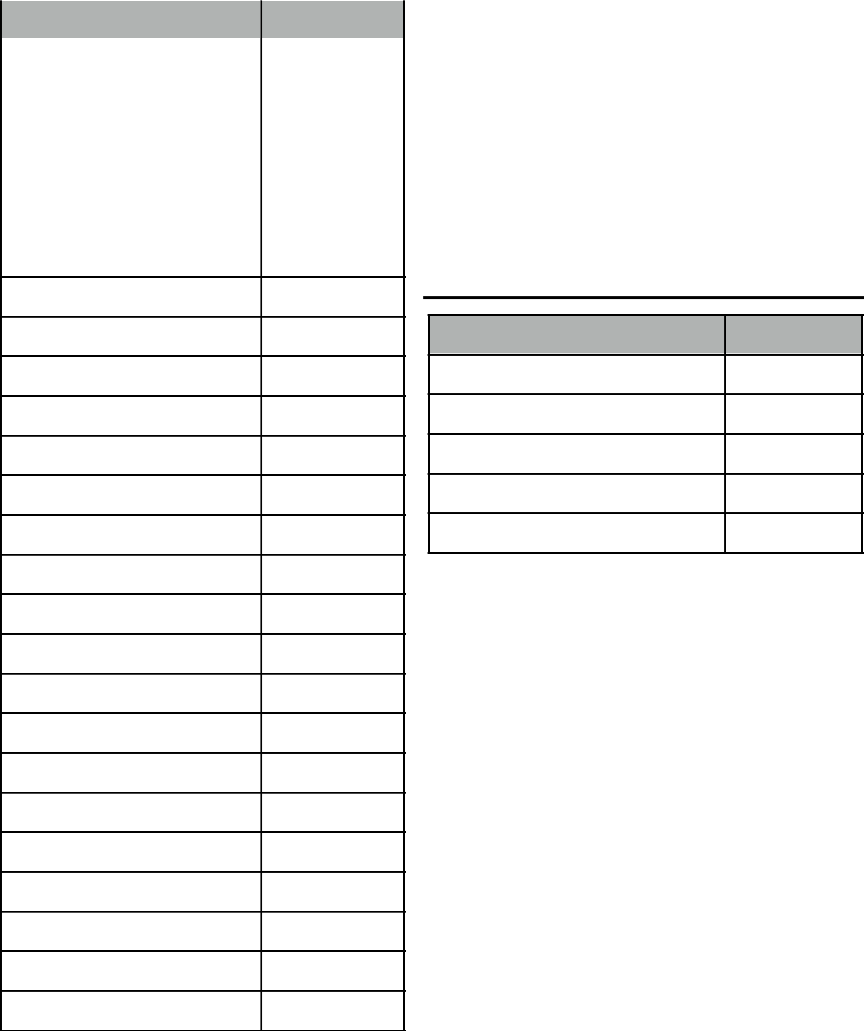

Amount in Savings

Transfer to Bills Account:

Transfer to Spend Account

Cash Withdraw

Amount left in Savings

Total Bills for the Week*

*This amount goes in “Transfer to Bills Account” box

