
Weekly Expense Tracking

If you don’t know where your money is going, it’s time to start tracking your spending. Different methods of tracking work for different people – some like to save receipts while others prefer to jot down all purchases in a small notebook they carry with them. Remember, tracking is only effective if you count every expense, including the morning newspaper and the change you put in the office vending machine. Use the sheets on the next two pages to record weekly and monthly spending totals. (Make copies of the charts so that you can track for longer than one week.)
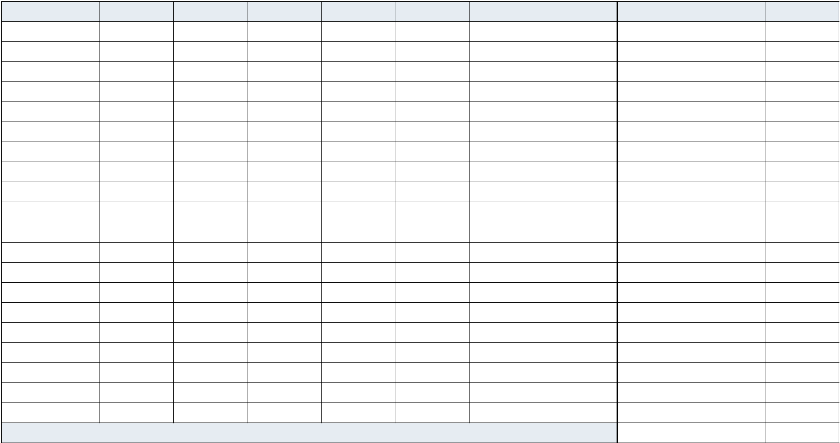

Item | Mon | Tue | Wed | Thu | Fri | Sat | Sun | Total Expenses Weekly BudgetOver / Under

Groceries

Restaurants

Laundry/Dry Cleaning

Medical/Dental

Auto/Gas/Parking

Other Transportation

Child Care

Personal Care

Clothing

Bank Fees/Postage

Entertainment

Books/Music/Video

Cigarettes/Alcohol

Gifts/Cards

Home/Garden

Church/Charity

Savings

Other

Other

Other

Weekly Totals

BALANCE, 595 MARKET STREET, 16TH FLOOR, SAN FRANCISCO, CA 94105 • 888-456-2227 • WWW.BALANCEPRO.NET • COPYRIGHT © 2006 BALANCE
Monthly Expense Tracking
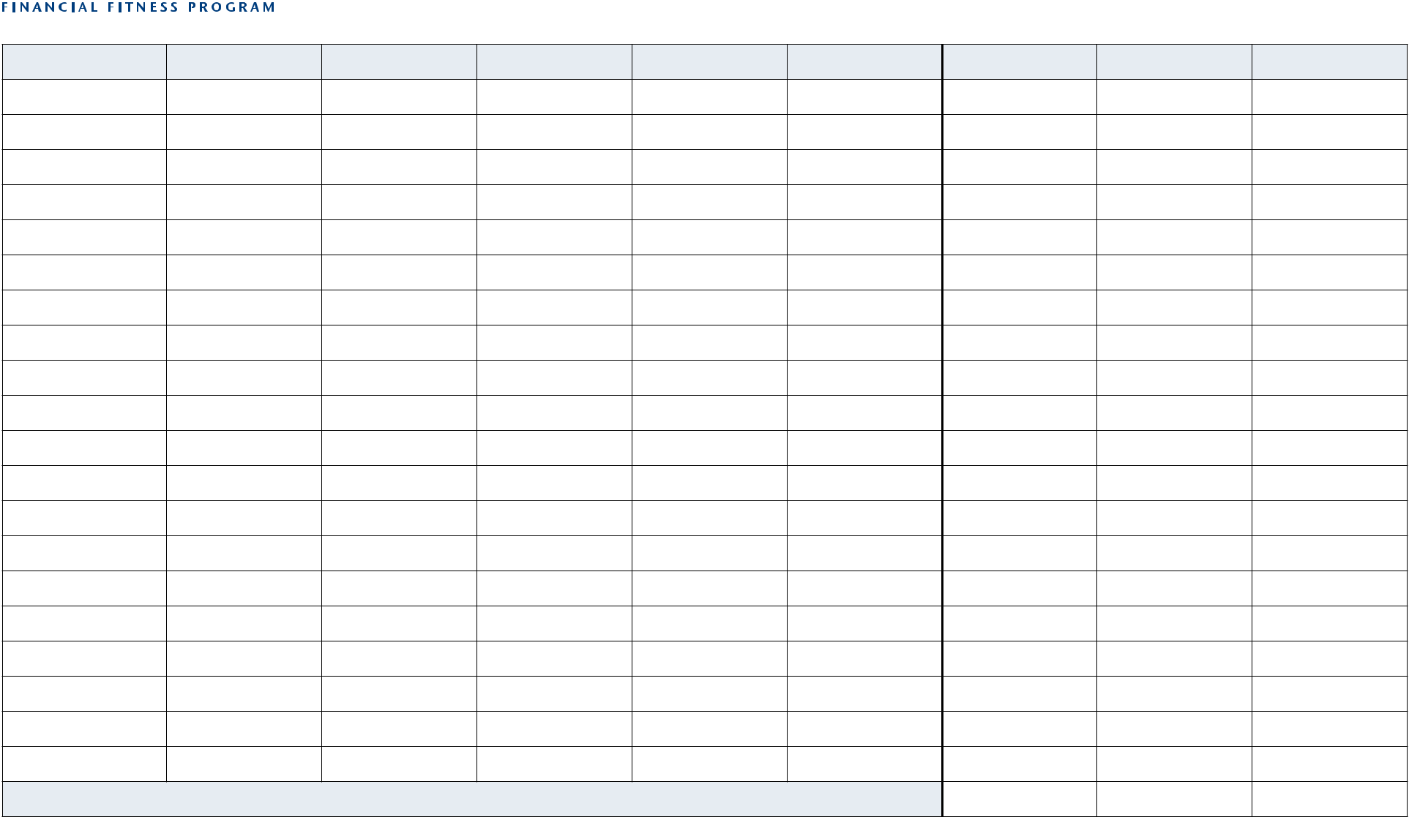

Item | Week 1 | Week 2 | Week 3 | Week 4 | Week 5 | Total Expenses | Monthly Budget | Over / Under

Groceries

Restaurants

Laundry/Dry Cleaning

Medical/Dental

Auto/Gas/Parking

Other Transportation

Child Care

Personal Care

Clothing

Bank Fees/Postage

Entertainment

Books/Music/Video

Cigarettes/Alcohol

Gifts/Cards

Home/Garden

Church/Charity

Savings

Other

Other

Other

Monthly Totals

BALANCE, 595 MARKET STREET, 16TH FLOOR, SAN FRANCISCO, CA 94105 • 888-456-2227 • WWW.BALANCEPRO.NET • COPYRIGHT © 2006 BALANCE

