Power of Attorney Letter

I hereby authorize the following person to act as a representative on my behalf/ my minor child to:

to submit my visa application

to make additions or changes to the application form

to sign consent/declarations relating to the visa application (except the signature on the application form)

to collect travel document (passport) from the visa application centre

Information about representative
 | Surname: |  | First name:
 |  | Proof of identity:
 | (Travel document and/or domestic Russian passport) |  |  | (document number)
 | (Mobile) Phone:

Information about yourself (person granting the power of attorney)

Note: in case of minors, either of the parent / guardian is requested to sign the power of attorney.
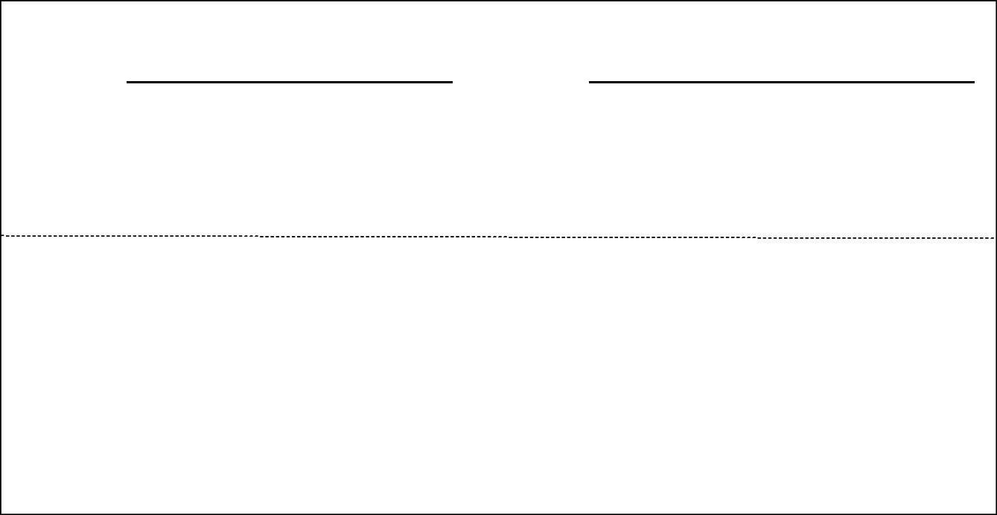

Visa Applicant:

Surname: First name:

proof of identity:

 | (Travel document and/or domestic Russian passport) |  |  |  |  |  |  | (document number)
 |  |  | Visa Applicant (Minor):
Surname: |  |  |  | First name:

proof of identity:

 | (Travel document and/or domestic Russian passport)
 |  |  |  |  |  | (document number)
Place and date: |  |  |  | Signature:

Please enclose a copy of the above mentioned proof of identity of the person who has been issued the power of attorney (travel document or domestic Russian passport).

