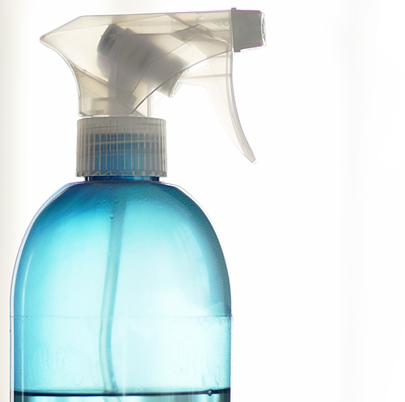

House

Cleaning

Service

Describe your fantastic cleaning service here I bet you are the premiere
service in town, helping countless busy families to keep their home
spotless and white glove certified. Use descriptive adjectives that make
everything sound cheerful; such as spiffy, shiny, and squeaky.

Say goodbye to a dirty house forever...
YOUR LOGO
- Dusting
- Dirt Deviling
- Steam Cleaning
- Vacuuming
- Moping
- Sweeping
- Washing
- Tidy up

Business Name | Phone | Address | Email | Web

