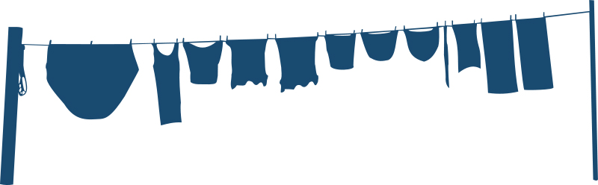
LAUNDRY SERVICE
- Feature One
- Feature Two
- Feature Three
- Feature Four
PHONE
WEBSITE

CONTACT INFORMATION

HOURS OF OPERATION
- Service One
- Service Two
- Service Three
- Service Four
“Enter a tagline about cleaning clothing.”

