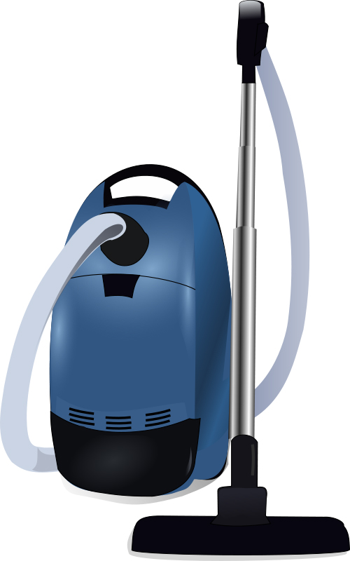
CALL TODAY FOR A FREE ESTIMATE 123-456-9021
Carpet Cleaning Flyer Templates
“We sweep the competition away.”

FEATURES
Each area is an individual text box that you can click on and type in your custom business information.
This is a pretty cool flyer www.cleaningflyer.com makes creating a carpet cleaning poster really easy.
You can use this text box to provide some unique selling points about your product or services.

BENEFITS

EXAMPLES

Name | Website | Email | Other Info

