
Describe your green cleaning services here.
CALL FOR A FREE ESTIMATE 123-456-7890
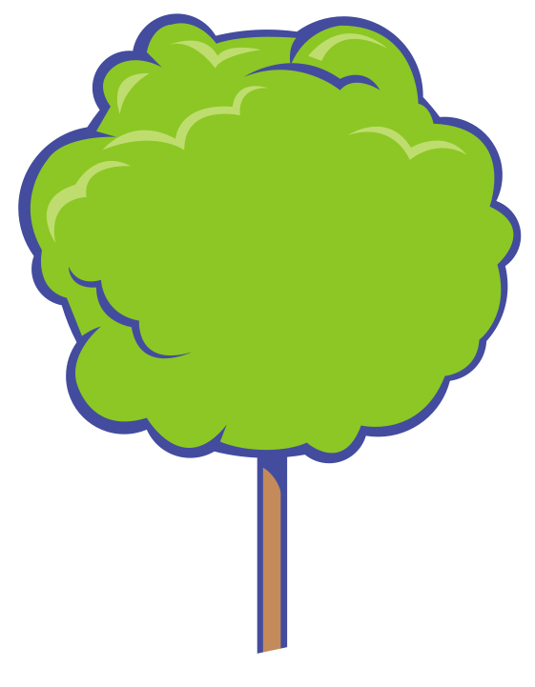
BIODEGRADABLE – NON-TOXIC – ALL NATURAL – CLEAN & SAFE
123 ADDRESS STREET, CITY, STATE 12345
“Natural Green Clean”

