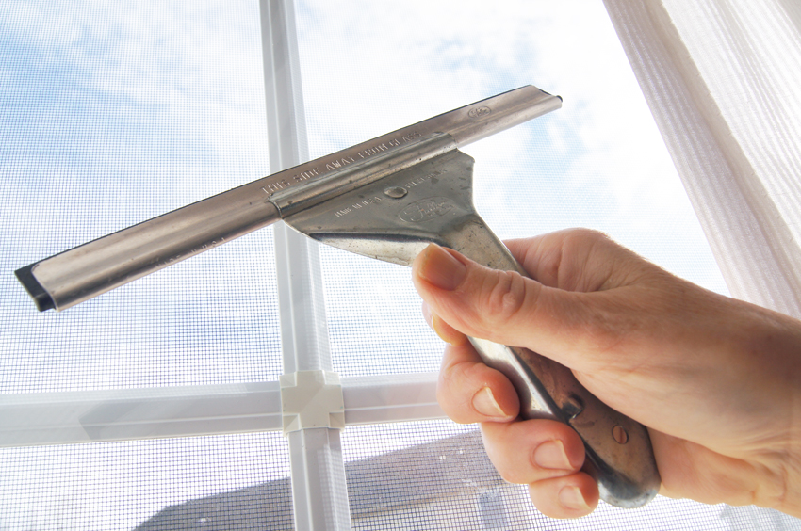

free window cleaning flyer
Small box to contain a one sentence of service related info or quote.
You can describe here what type of window cleaning services you offer – enter that information here whatever you have to say.

Orange Cleaning Service | Phone: 123-456-7890
Your Address or other information here.

