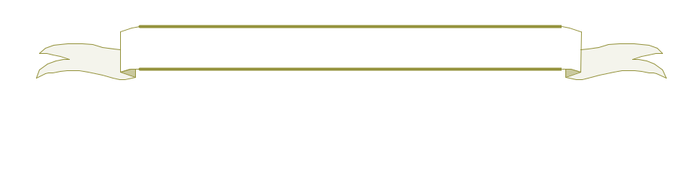
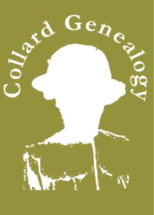
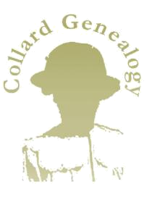
The SALTER Family
Robert Salter | M | Lavinia
B c1792 | M | B c1793
B c1792 | ??? | B c1793
Long Sutton | ??? | Chatteris
Lincolnshire |  | Cambridgeshire

Jane Salter | Sarah Salter | Hannah Salter | Caroline Salter | Eliza Salter |  | John Salter |  | Robert Salter
B c1825 | B c1825 | B c1829 | B c1829 | B c1831 |  | B c1835 |  | 1834-1899
 |  | Long Sutton | Long Sutton |  |  | Long Sutton |  | Long Sutton
 |  | Lincolnshire | Lincolnshire |  |  | Lincolnshire |  | Lincolnshire
 |  |  |  |  |  | Eliza Shickel
 |  |  |  |  |  |  |  |  | M
 |  |  |  |  |  | 1839-1874 |  |  | 1862
 |  |  |  |  |  | Whaplode Drove
 |  |  |  |  |  | Lincolnshire

Caroline Salter Robert Salter
B c1859 B 3rd Qtr 1863
Holbeach Long Sutton

Lincolnshire Lincolnshire

George Wright

B c1861

Fosdyke
Lincolnshire

Harriet Salter |  |  | George Salter | Mary Jane Salter
B 1st Qtr 1865 |  |  | B 2nd Qtr 1867 | B 1st Qtr 1869
Long Sutton |  |  | Long Sutton | Long Sutton
Lincolnshire |  |  | Lincolnshire | Lincolnshire
M
1906

Thomas Salter | Eliza Salter | Alice Salter |  | James Salter |  |  | Robert Salter | Fanny Salter | Mary Salter
B c1884 | B 2nd Qtr 1892 | B 4th Qtr 1894 |  | B 3rd Qtr 1897 |  |  | B 3rd Qtr 1898 | B 4th Qtr 1900 | B c1903
Long Sutton | Long Sutton | Long Sutton |  | Long Sutton |  |  | Lutton Marsh | Lutton Marsh | Long Sutton
Lincolnshire | Lincolnshire | Lincolnshire |  | Lincolnshire |  |  | Lincolnshire | Lincolnshire | Lincolnshire
 | Elizabeth Neve
 |  |  |  | M
 | B 2nd Qtr 1900 |  |  | 1922
 | Holbeach District
 | Lincolnshire
Muriel Salter | Ronald Salter | Hubert Salter | Gerald Salter | Audrey Salter | Vera Salter | Derick Salter | Dennis Salter
B 4th Qtr 1922 | B 2nd Qtr 1924 | B 4th Qtr 1926 | B 4th Qtr 1929 | B 3rd Qtr 1931 | B 2nd Qtr 1933 | B 3rd Qtr 1937 | B 3rd Qtr 1937
Holbeach District | Holbeach District | Holbeach District | Holbeach District | Holbeach District | Holbeach District | East Elloe District | East Elloe District
Lincolnshire | Lincolnshire | Lincolnshire | Lincolnshire | Lincolnshire | Lincolnshire | Lincolnshire | Lincolnshire

Betty Robinson
Betty Robinson |  | M
B 1938 |  | M
B 1938 |  | 1958
Fleet Nr Holbeach |  | 1958
Lincolnshire

Julie Salter | Martin Salter | Delia Salter | Helen Salter | Jayne Salter
B 1959 | B 1961 | B 1965 | B 1968 | B 1970
Holbeach | Long Sutton | Long Sutton | Long Sutton | Long Sutton
Lincolnshire | Lincolnshire | Lincolnshire | Lincolnshire | Lincolnshire

