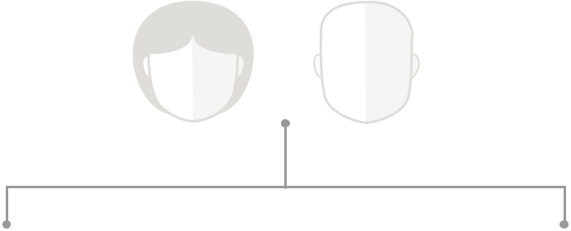

Owen Family Tree

Copyright ©2017 Engaged Ownership LLC.

No part of this document may be reproduced without the express

written permission of Engaged Ownership LLC.
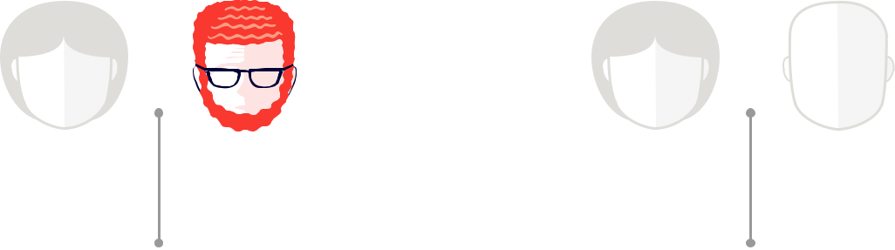

JOHN
OWEN

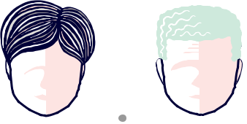

 | ALISON | CHARLIE
 | OWEN | OWEN



 | MIKE |  | MARTHA | RYAN | AMANDA |  |  | CHRISTOPHER
 | OWEN |  | OWEN JONES | JONES | OWEN COOPER |  |  | OWEN




JAMESON
JONES

