Family Tree
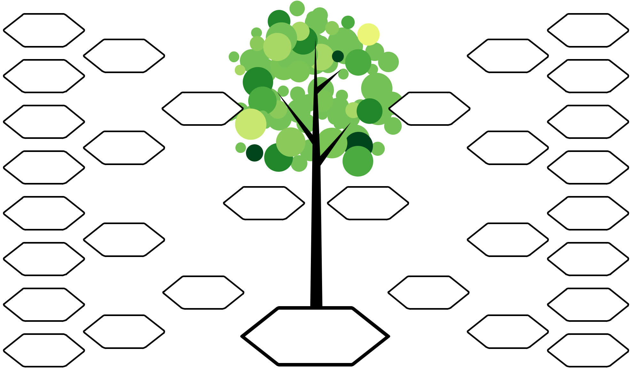

great-grandmother  great-grandmother

grandmother  grandmother

great-grandfather  great-grandfather

mother father

great-grandmother great-grandmother

 | grandfather | grandfather
great-grandfather |  | great-grandfather

ME

www.FreeFamilyTreeTemplates.com

