Disciplinary Action Form

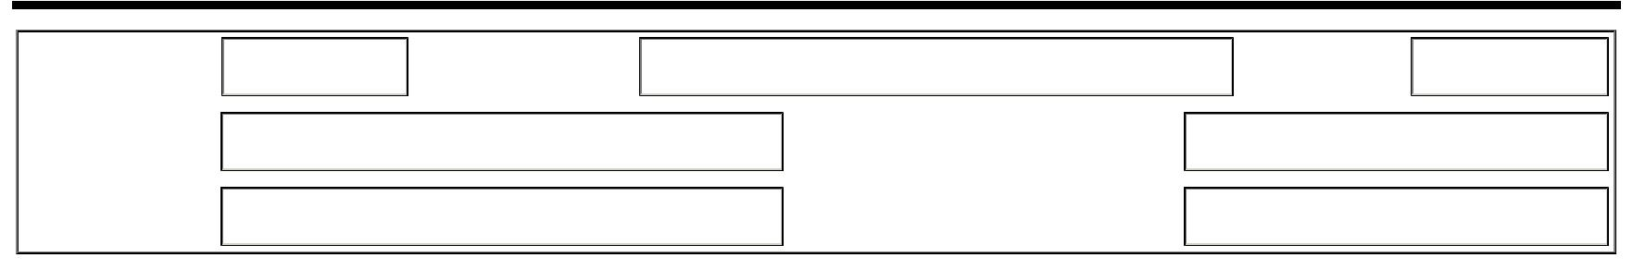

Date: Employee Name: Date of Hire:

Department: Employee ID#:

Manager Name: Manager ID#:

Action Taken

Date of Counseling:

 Verbal Counseling (For departmental use only, not to be included in Personnel Record)

Written Counseling (Manager should consult with Office of Student Employment prior to written counseling)

Final Written Counseling (Manager should consult with Office of Student Employment prior to final written counseling)

Addendum to Counseling (Include attachment(s) for explanation and condition of above actions)

Reason for Counseling:

Recommendation For Improvement:

Action Taken:

Employee Comments/Remarks:

Employee note: Failure to improve conduct and/or further violation of policy will result in additional disciplinary action, up to and including discharge. Signing this counseling form does not indicate your agreement with this record but indicates that you have reviewed the content herein.

Employee Signature | Date |  | Manager Signature | Date
OSE Signature | Date

