Student Disciplinary Action Form

Student Name __________________________________________________
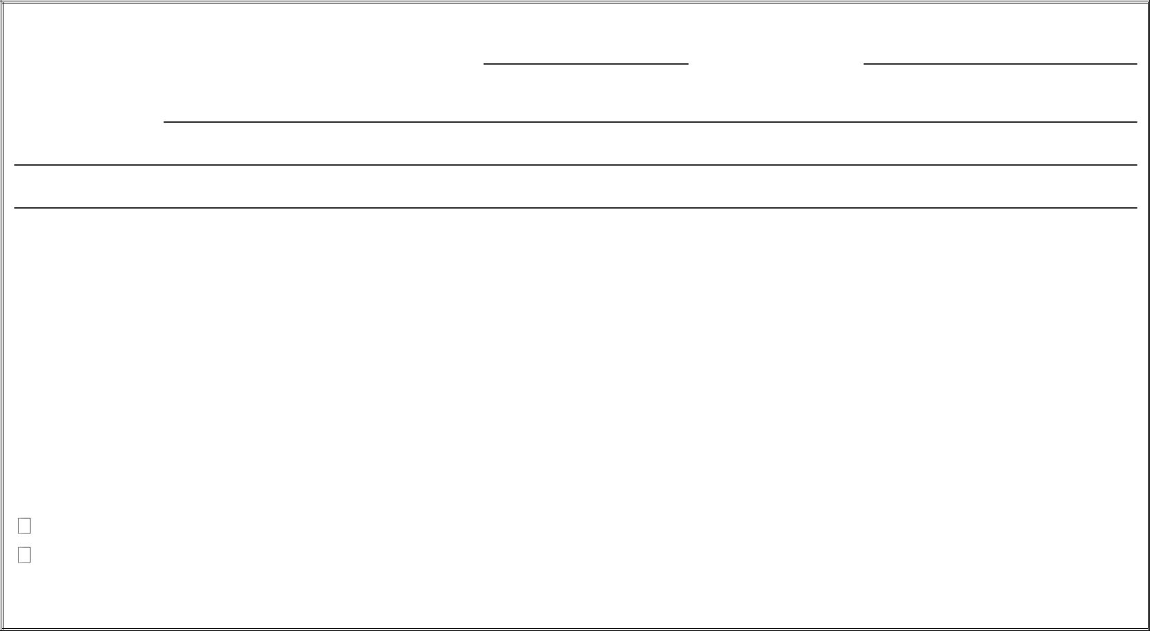

First Warning Date/Time of Infraction: Location:

Description:

Corrective Actions Taken: ____________________________________________________________________

__________________________________________________________________________________________

__________________________________________________________________________________________

__________________________________________________________________________________________

Supervisor Signature |  |  |  | Date
Student Signature |  |  |  | Date
I agree
I disagree
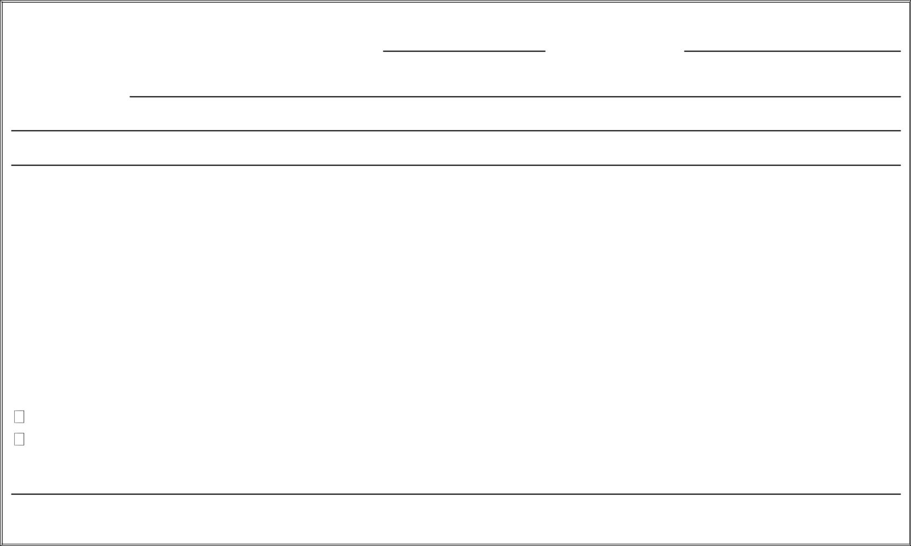

Second Warning Date/Time of Infraction: Location:

Description:

Corrective Actions Taken: ____________________________________________________________________

__________________________________________________________________________________________

__________________________________________________________________________________________

__________________________________________________________________________________________

Supervisor Signature |  |  |  | Date
Student Signature |  |  |  | Date
I agree
I disagree

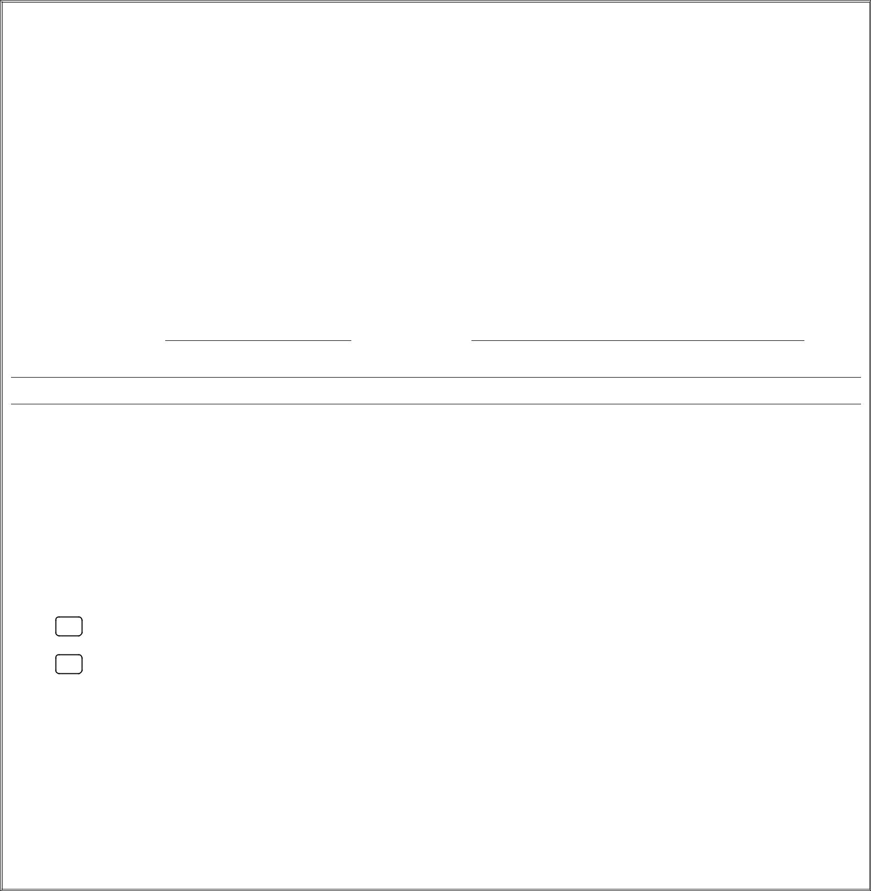
THIRD AND FINAL INFRACTION

As the third and final write-up, the supervisor must consult with the Labor Program Office and determine the next course of action which may involve one or more of the following:

- Departmental Probation (This disciplinary action must be taken when the supervisor decides to allow the student to continue working in the department. The supervisor will be required to develop an accountability agreement outlining specific expectations. If a student disregards the accountability agreement, appropriate actions will be taken at the discretion of the Labor Program Office which may involve a departmental release, labor probation and/or labor suspension. An electronic template of this form is available

- Departmental Release (This disciplinary action is taken when the supervisor believes all resources have been exhausted and the student doesn’t have the ability to be successful within their present labor assignment. The Labor Program retains the right to reassign the student to the area of greatest need when a released occurs based on nonperformance issues. If a prior accountability agreement was developed, it should be attached along with the Labor Release and Adjustment Form. The release of any freshman requires approval from the Labor Program Office.)

Date/Time of Infraction: Location:

____________________________________________________________________________________________________________

____________________________________________________________________________________________________________

Corrective Actions Being Recommended by Supervisor: ______________________________________________________________

____________________________________________________________________________________________________________

____________________________________________________________________________________________________________

____________________________________________________________________________________________________________

Corrective Actions Taken:

- Departmental Probation

- Departmental Release (Release of freshman students requires approval from the Labor Program Office)

_________________________________________________ ____________________________
Supervisor Signature Date

_________________________________________________ ____________________________
Student Signature Date

_________________________________________________ ____________________________

Labor Program Office Staff Date

