 |  |  |  | 03/12/15
ORDERED |  | SHIP
BY: |  | TO:
THOMAS R BROWN |  | THOMAS R BROWN
1234 SAMPLE STREET STE 250 |  | 1234 SAMPLE STREET STE 250
WESTBOROUGH MA 01581-3960 | UNITED STATES | WESTBOROUGH MA | 01581-3960 | UNITED STATES
 |  | CUSTOMER # | 55

PICK SLIP MESSAGE 1 FIRST LINE

PICK SLIP MESSAGE 1 SECOND LINE

PICK SLIP MESSAGE 1 THIRD LINE

order header message 1 order header message 2 order header message 3 order header message 4
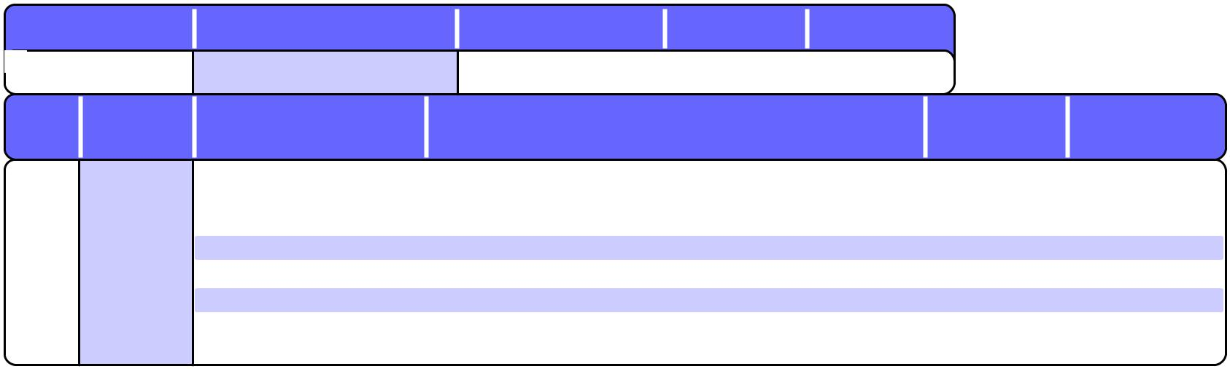

 |  | DATE OF ORDER |  |  |  |  |  | PURCHASE ORDER NO. |  |  |  |  |  | CUSTOMER NO. |  |  |  | ORDER NO. |  |  |  | PAGE NO.
 | 03/12/15 |  |  |  |  | 3415 |  |  |  |  |  |  | 55 |  |  |  | 5143 |  |  |  | 1
 |  | LINE |  | ITEMS |  |  |  | ITEM NUMBER |  |  |  |  |  |  | DESCRIPTION |  |  |  |  |  |  |  |  |  | UNIT PRICE |  |  |  |  | EXTENSION
 |  | NO. |  | SHIPPED |  |  |  | ITEM NUMBER
 | 1 |  | 2 |  |  |  | RF1234567890 |  |  |  | NESTING 8 PIECE STAINLESS STEEL COOKWARE |  |  |  |  |  |  |  |  |  |  |  |  |  | 199.99 |  |  |  | 399.98
 |  |  |  |  |  |  | order line message 1
 |  |  |  |  |  |  | order line message 2
 |  |  |  |  |  |  | order line message 3
 |  |  |  |  |  |  | order line message 4
 | 2 |  | 2 |  |  |  | RF123SKU4567 |  |  |  | WOMEN'S ALL WEATHER PACKABLE RAIN JACKET |  |  |  |  |  |  |  |  |  |  |  |  |  | 119.00 |  |  |  | 238.00
 |  |  |  |  |  |  | ROSE XSML WMNS |  |  |  | WOMEN'S X-SMALL ROSE POCKET RAIN JACKET

